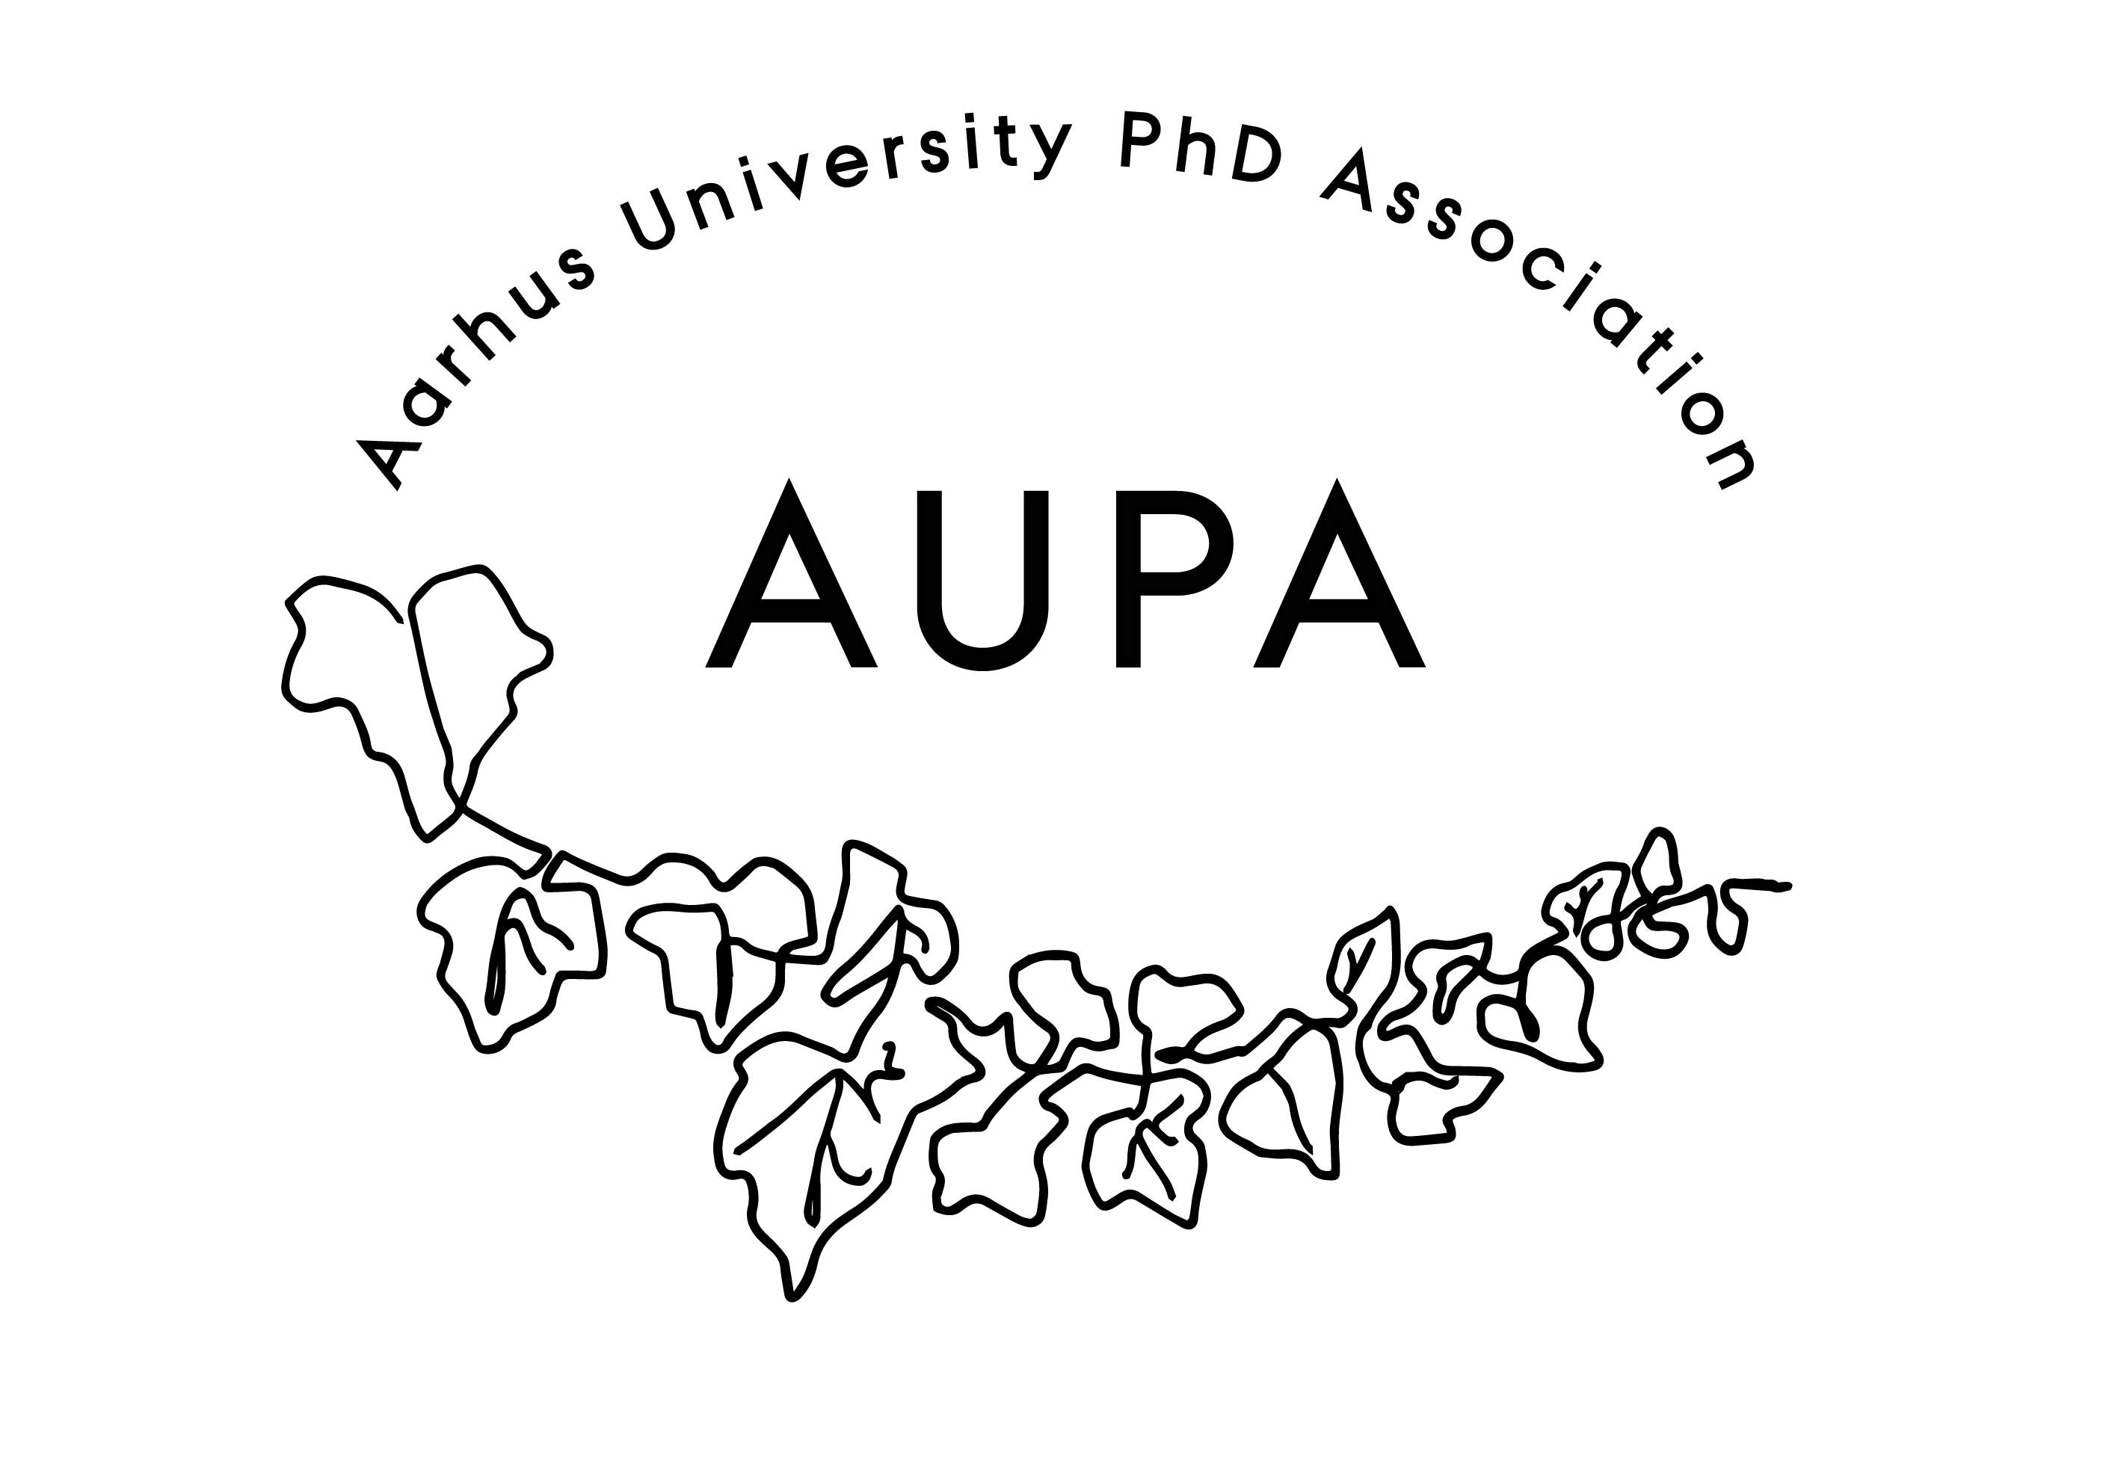
AGENDA FOR AUPA’S BOARD MEETING

TIME: May 8th 4-5 pm
LOCATION: 5220 - 214

Attendees:
ABSENT WITH APOLOGY:

- Welcome

- Formalities
  - Election of chairman
  - Can this this agenda be approved?
  - Approval of minutes from the last meeting (available via Teams)

- News
- PAND
- HAMU
- Emails

- Status from the strategy group
  - Working hours
  - Sexism in science

- Status from the events group:
  - Social activity group
  - AI event with Junior Research Assoc.
  - Event for internationals with Studenterhuset? (recap on talk w. Sigrun)

- Deciding on the date for the next board meeting

- Any other business?
  - Future meeting focus:
  - Groups:
    - Strategy group:
    - Events group:

Deciding on topics for next meeting
- ECTS points for going abroad - HE vs BSS (Michelle)
- AUPA summit

