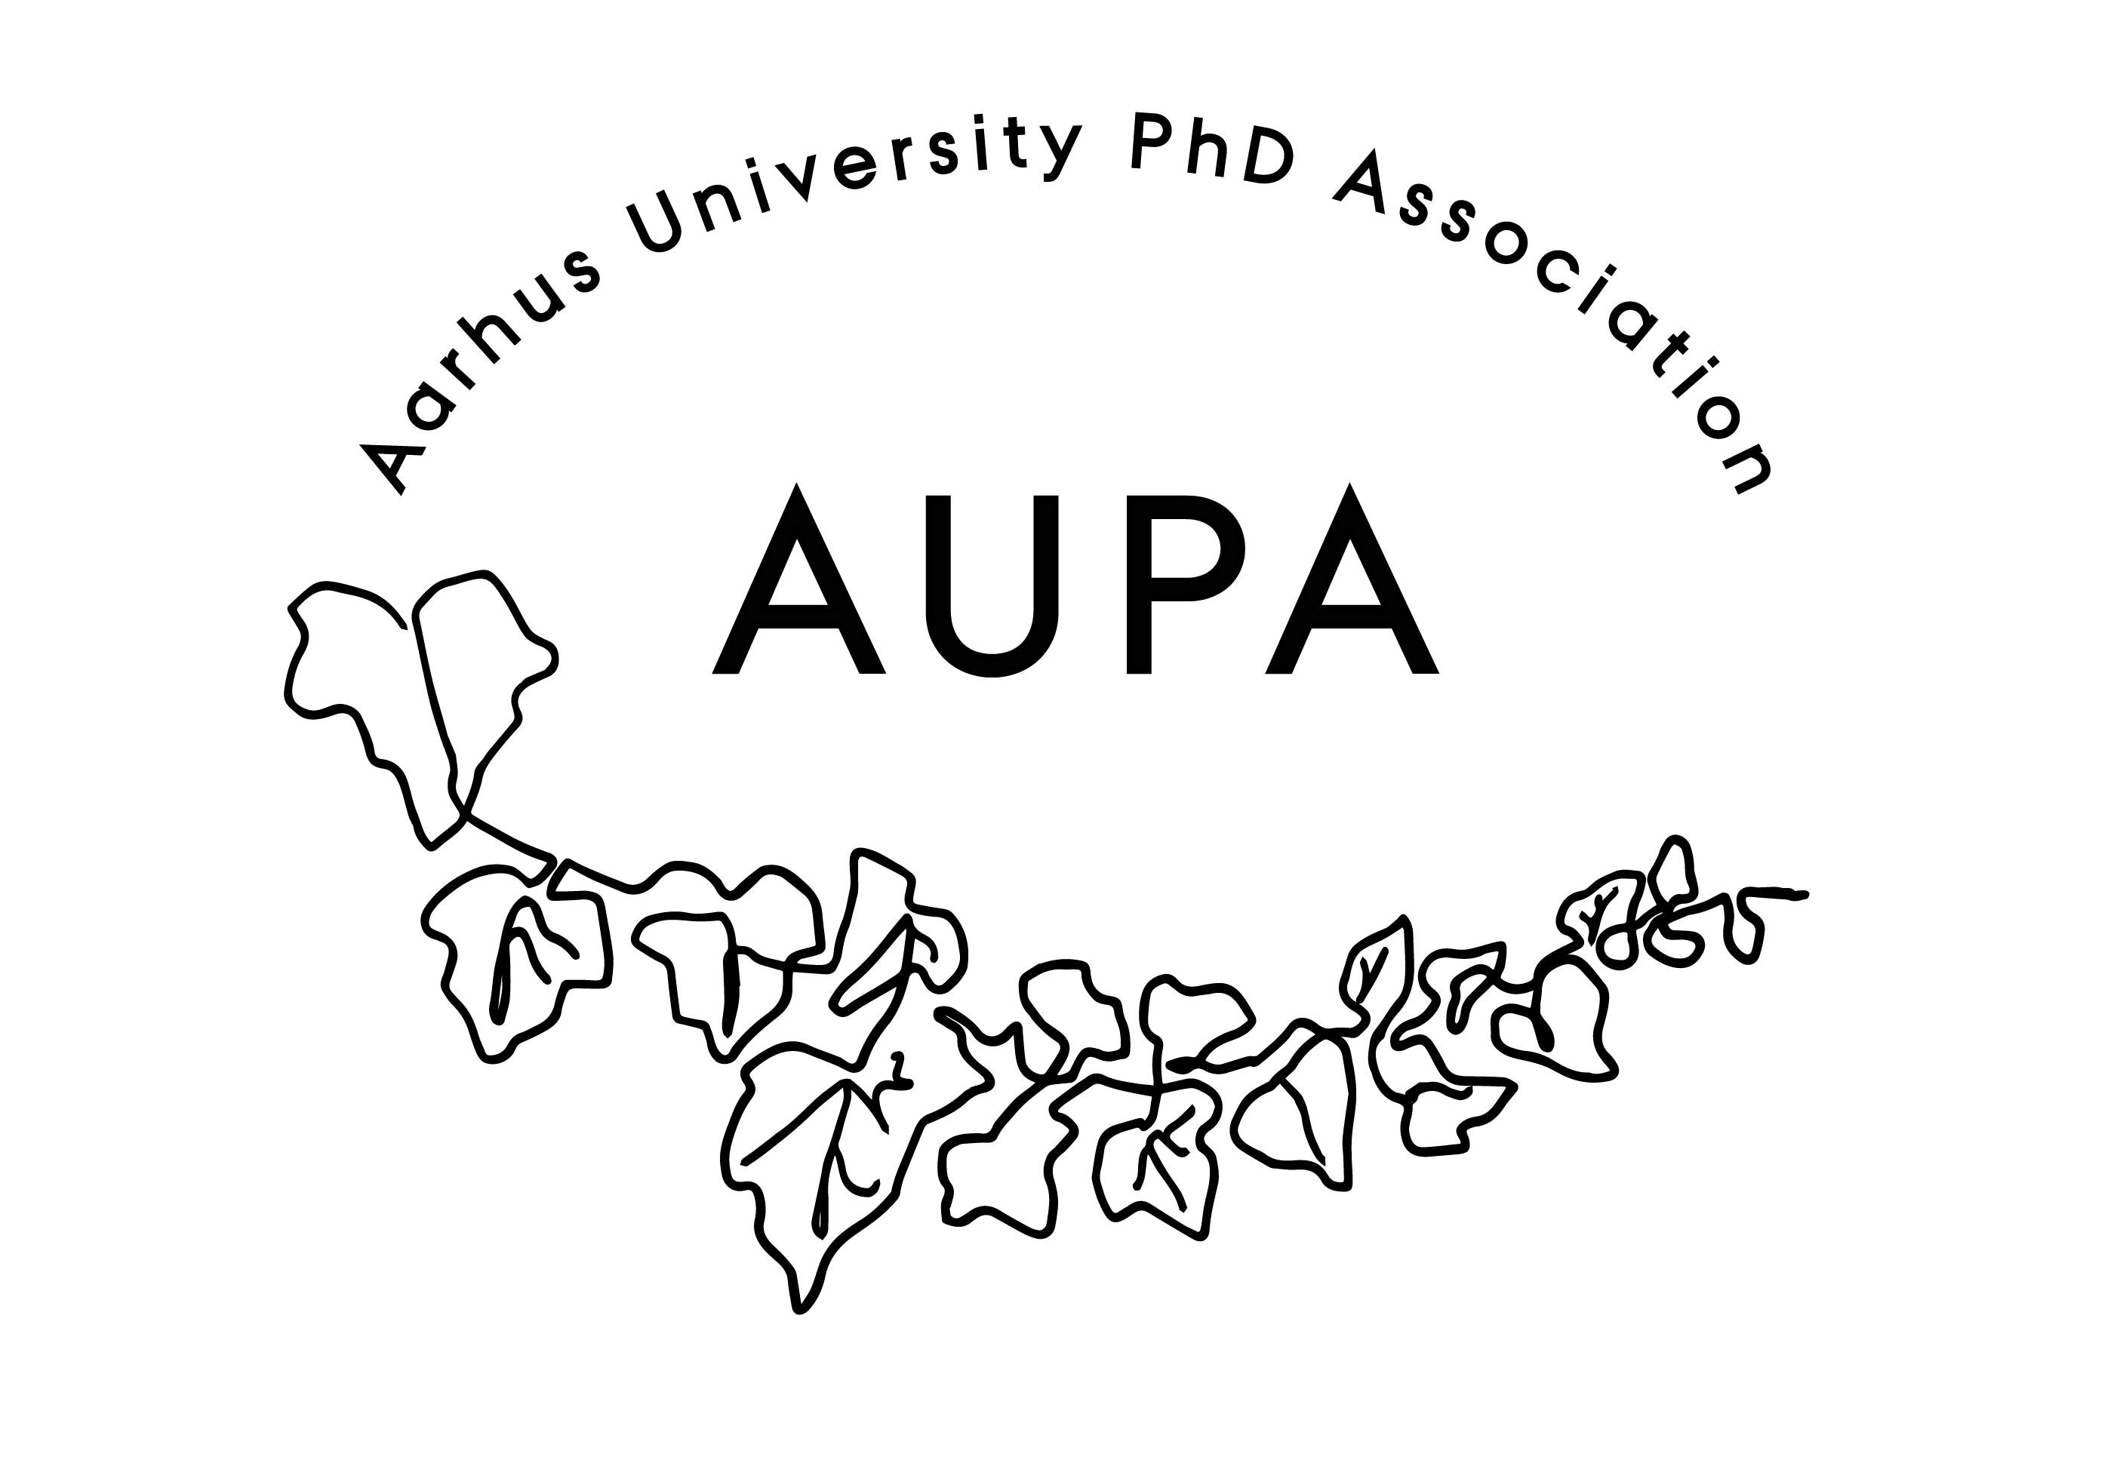AGENDA FOR AUPA’S BOARD MEETING

TIME: July 31st 15-16 o’clock

LOCATION: 1520-237

Attendees:

ABSENT WITH APOLOGY:

1. Welcome
2. Formalities
   * Election of chairman Thomas
   * Can this this agenda be approved? Yes
   * Approval of minutes from the last meeting Yes (there are on the website)
3. News

* PAND Summer holiday. Planning Eurodoc 2025. When can/should we apply for money
* HAMU not that much new. But Rigsrevisionen (perhaps) decided that new EU work time regulation doesn’t contain PhD students (“selvtilrettelæggere” =self-organizers)
* Emails. Sexism-channels (see the comment attached to this meeting) + PhD-portrait project (see beneath)

1. Todays topics

* Mini portrait project to attract candidates to the election to the PhD Committee. Still missing two PhD’s for the AU Election-“campaign”

Discussion on what events should be reoccurring in AUPA – Anne-Marie has searched Teams

How to make the what to do if you experience sexism-channels more visible to PhD students (see appendix)

Should we have an Instagram? Someone in charge of SoMe at least

Overlapping meetings with the Activity Group? E.g. the AI-event – cooperate with the Activity Group (maybe replace the AI-event with something else, since it has been dragged on for too long)

1. Status from the strategy group

Summit August 14th where we’ll develop what to show the PhD School Leaders on September the 4th. Theme: Work time and other topics from all the PhD students

Meeting between the chairs and Thomas and Niels (new head of the PhD School Leaders) and Kristian on August the 15th

From here: Working hours theme 🡪 interesting with a work/life-balance workshop. More interesting if we mix “how to success in academia” into it for a different touch - “how to function in your work” (self-expectations; stress management). Get someone who’s hiring the post-PhD’s (maybe one from the industry besides one from academia)

Summit should be a reoccurring event in AUPA (e.g. for political legitimacy)

Strategy group will meet after the Summit before the school leaders

1. Status from the events group

Summit in August (Anne-Marie will order sandwiches+coffee+cake)

PhD School Leader meeting in September

Studenterhuset event in September. We need advertising (the next PhD School newsletter + Facebook + poster) and foods and some senior people to stand up and say something)

Conference in October. We should rather have a speaker from inside the university. A small workshop. Team up with the Activity Group? Last year advertising was = Facebook + LinkedIn + news letter + the Career service + Studenterhuset + posters? Theme should be work time, stress management, what to do to become a good post-project PhD (speakers from Novo Nordisk and a professor, …McKinsey). NB! It just has to be before the next general assembly (doesn’t have to be in October, if we can’t make it)

Introduction days (in January)

We should have an event group meeting in August

1. Deciding on the date for the next board meeting = overlapping meeting joint meeting half-half theme: How to cooperate more. Week 34-35
2. Any other business?
   * + SU will be reduced for MA students – what happens with the 4+4?

Deciding on topics for next meeting: