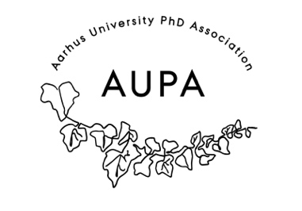

AGENDA FOR AUPA’S BOARD MEETING

TIME: November 19th 4 PM

LOCATION: 1520-237

Attendees:

ABSENT WITH APOLOGY:

1. Welcome
2. Formalities
   * Election of chairman
   * Can this agenda be approved?
   * Approval of minutes from the last meeting (they are on the website)
3. News

* PAND
* HAMU

1. Todays topics

* November Conference

1. Advertisement of the event through the PhD and Postdoc activity group pages, in buildings and Thomas will also try writing to the PhD school representatives. Also through word of mouth.
2. Discussed the Human Bingo model  (the activity group has made a wordoc/poster on it)and the time frame of the event which is:

Presenters ( 10 min each) \*3  -  40 min

Break (10 min)-   50 min

Reflection (10 min)- 60 min

Panel (20 min)- 80 min

Wrap-up (5 min)- 85 min

Bingo (25 min)- 110 min

Bingo wrap up(5 min)- 115 min

Transition (5 min)- 120 min

Marius will once again write to the speakers about the time given to be spoken.

1. Buying of small gift baskets for the guests (Shubhangi)
2. Martin will once again look into re-designing the poster
3. Status from the strategy group
4. Status from the events group
5. Deciding on the date for the next board meeting
   * Between 2nd December and 16th December
6. Any other business?

Deciding on topics for next meeting: