
AGENDA FOR AUPA’S BOARD MEETING
TIME: October 9th from 17:00-18:00
LOCATION: 1520-216

Attendees:
ABSENT WITH APOLOGY:

- Welcome

- Formalities

  - Election of chairman
  - Can this agenda be approved?
  - Approval of minutes from the last meeting (they are on the website)

- Today’s topics:
- Evaluation of Student Council Workshop: What did we learn?
- November conference
  - What is the theme? Stress
  - KIP (quality In PhD progress)
  - Invite a PhD school leader?
  - What is Activity Groups Role?
- Intro-days
  - How did the first one go?
- Looking at the plan for the year and month
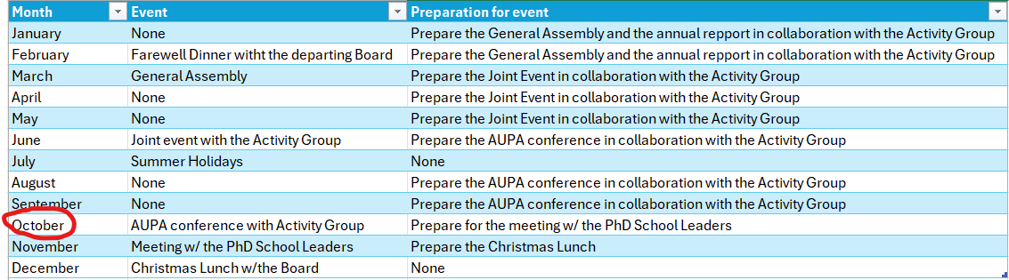

Deciding on topics for next meeting:

When should the next meeting be held?

