
MINTES FOR AUPA’S BOARD MEETING
TIME: October 9th from 17:00-18:00
LOCATION: 1520-216

Attendees:
ABSENT WITH APOLOGY:

- Welcome

- Formalities

  - Election of chairman
  - Can this agenda be approved?
  - Approval of minutes from the last meeting (they are on the website)

- Today’s topics:
- Evaluation of Student Council Workshop: What did we learn?
  - Very good
  - Writing workshop on the 3. Of November – 16:00-17:00
- November conference
  - Last conference: Invite a professor from HE department and a scientist from Arla. Gave their own perspectives on academia after your PhD. Monica talked – not recommended. Bring in people from AU.
  - AUPA does conference, AG does a fun event after that has to do with the theme. Food together after.
  - Tasks:
    - William Scarf auditorium – 20/25 people. Booked!
    - Publicity: How do we get people? We need to time it. Invite people from HE.
      - Rebecca: Make tentative invitation: Before we have the speakers.
    - Time: December 2nd from 16:00-19:00
    - Theme: Mental health/stress
    - Speakers: Who do we want?
      - Motivational speaker.
      - Maybe a Psychology professor.
      - Stine: Karen Johanne Pallesen: The science of stress.
      - Rebecca: HEs wellness person
      - Sara: Arts PhD school leader: Marianne s.
      - Each speaker talks for 15/20 minutes.
    - Food: Pizza
    - Audience: Invited though CM – facebook, Linked in, Newsletter, posters.
    - Activity Groups Role: Do a fun event. 30/40 mins. Speakers don’t stay, but audience does. Maybe some teambuilding, getting to know other people, conversation cards, how to talk about difficult subjects.
    - KIP (quality In PhD progress)
    - Moderator: Decide at the meeting leading up to the conference

- Intro-days
  - How did the first one go?
  - Went well, but needed feedback – need the right slides to make the edits in.
    - Shubhangi sends old slides
    - Make new slides
    - Put everything in a Teams folder – Rebecca makes teams folder.
- Looking at the plan for the year and month
  - Meeting with PhD School leader
    - Slide presentation of 4/5 points (e.g. workhours, discrimination, Stress, ECTS)
    - They pick up one or two points that they go forward with
    - They contact us for the dates – Kristian
    - December/January
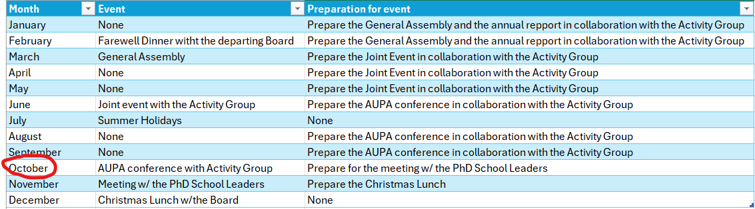

- Electing a new chair
  - Shubhangi is stepping down as Chairperson
  - Stine will be the new chair! Yay!
  - Teams folder for formal ideas

Deciding on topics for next meeting:
- Conference
- Evaluation of writing-workshop – what did we come up with
- Meeting with PhD Schoolleaders
- Talk about KIP
- Christmas Lunch planning

When should the next meeting be held?
End October beginning of November
Rebecca makes doodle

Other:
- Competition: AU 3R
  - Chair of AUPA sits in the Jury – is anyone interested?
  - 8th of March 2026 from 16:00

- Next Newsletter: Advertise for facebook and linked in.
- Doodle for next meeting
- Social activity with AUPA and AG
- Intro days – Be aware in winter

- PhD days – AUPA has stand with banner. (HE – 16th of January)

- Update the website – Mail people inactive on the mail list

