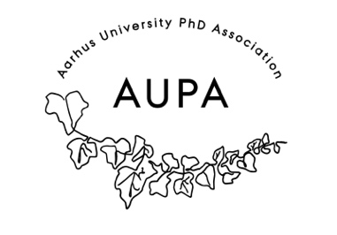
MINUTES FOR AUPA’S BOARD MEETING (before pétanque event)
TIME: August 11th from 16:00-17:00
LOCATION: 1520-216

Attendees:
ABSENT WITH APOLOGY:

- Welcome

- Formalities

  - Election of chairman
  - Can this agenda be approved?
  - Approval of minutes from the last meeting (they are on the website)

- Today’s topics:
- Petanque Event on August 21st (5-7 pm)

Information about event: Goal is to recruit new members to AUPA
      - Stine is in charge of pétanque equipment - 2 sets
      - Shubhangi is in charge of bringing drinks
      - Location: Ingerslevs boulevard, Go to Streetfood after
      - Advertisment: Come and meet the board and play games – flyers around campus, maybe make flyers we can hand out to new members at event

What to do at the event?
- Alexandra brings drinks (soda – non-alcoholic, “ish-brand” of non alcoholic drinks, chips, rubbish bags)
- Everyone brings blankets
- Rebecca makes flyer – meet and greet – bring a PhD or AU friend – make QR-code with sign up link.
- Rebecca Send applicant list a couple of days before
- Make a little flyer to hand out at the event

Deciding on topics for next meeting:
- Date for when the studenterråd person should come

When should the next meeting be held?
2,3rd week of September – make Doodle

Alexandra stepping down – Sarah replacement

