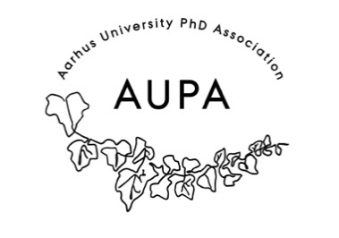
MINTES FOR AUPA’S BOARD MEETING
TIME: October 9th from 17:00-18:00
LOCATION: 1520-216

Attendees:
ABSENT WITH APOLOGY:

- Welcome

- Formalities

  - Election of chairman
  - Can this agenda be approved?
  - Approval of minutes from the last meeting (they are on the website)

- Today’s topics:
- Evaluation of Writing workshop: What did we learn?
- December conference
  - Speakers: Who do we want?
    - Karen Johanne Pallesen: The science of stress.
    - Other?
  - Who will be the moderator?
  - Activity group?
- Christmas lunch planning
- What is health doing?
  - Fokus on visibility and membership growth

