
MINUTES FOR AUPA’S BOARD MEETING (before pétanque event)
TIME: September 16th from 17:00-18:00
LOCATION: 1520-216

Attendees:
ABSENT WITH APOLOGY:

- Welcome

- Formalities

  - Election of chairman
  - Can this agenda be approved?
  - Approval of minutes from the last meeting (they are on the website)

- Today’s topics:
- Evaluation of Petanque Event on August 21st (5-7 pm)
- Date for Studenterråd workshop – maybe with Activity Group
- Octobers conference
  - What is the theme?
  - Invite a PhD school leader?

- Intro-days
  - Natural and Technical Sciences and their Introduction Day is on the 6th of October.
  - PhD students at TECH on Tuesday, 11 November 2025.
  - GSNS's Introduction Day on 6 October 2025
- Working with the other PhD associations (Health, PhD committee, maybe others?)
- Looking at the plan for the year and month
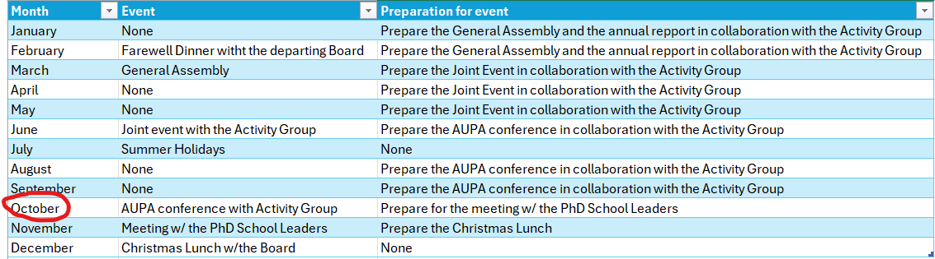

Deciding on topics for next meeting:

When should the next meeting be held?
Make doodle

