
MINUTES FOR AUPA’S BOARD MEETING
TIME: September 16th from 17:00-18:00
LOCATION: 1520-216

Attendees: Stine, Sara, Sara
ABSENT WITH APOLOGY:

- Welcome

- Formalities

  - Election of chairman
  - Can this agenda be approved?
  - Approval of minutes from the last meeting (they are on the website)

- Today’s topics:
- Evaluation of Petanque Event on August 21st (5-7 pm)
  - Bad weather
  - Two people showed up
  - Good event – hard to find
  - Good with snacks and drinks
- Date for Studenterråd workshop – maybe with Activity Group
  - Doodle – couple of dates - Late September start October
  - sad@cas.au.dk
- Octobers conference
  - What is the theme?
    - Stress
    - Application process
  - Invite a PhD school leader?
- Intro-days
  - Natural and Technical Sciences and their Introduction Day is on the 6th of October. 12:45-13:00
  - PhD students at TECH on Tuesday, 11 November 2025. 11:30
- Working with the other PhD associations (Health, PhD committee, maybe others?)
  - Good idea
  - Maybe invite Health to a meeting
- Looking at the plan for the year and month
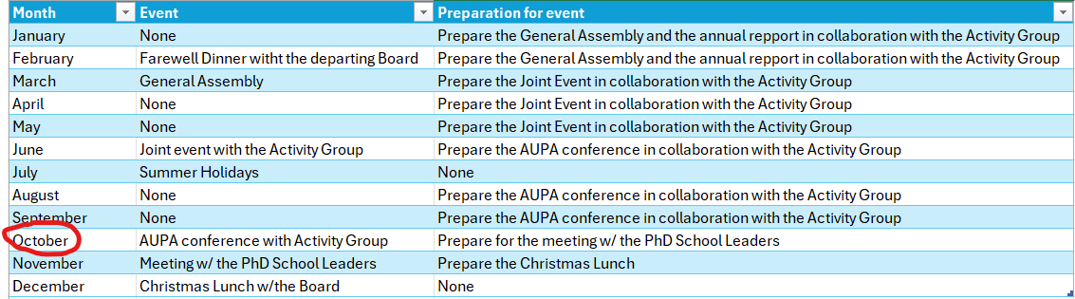

Our goals for the organization:
- Stress (expectation for PhD students, work hours)
- Application process

Deciding on topics for next meeting:

When should the next meeting be held?
Make doodle (Late September, start October)

Rebecca Tasks
Add sara and sara to teams Channel and maillinglist
Have meeting with Shubhangi
Teams mappe til meetings and minutes

