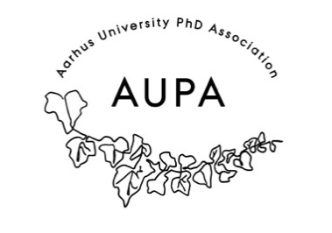
MINTES FOR AUPA’S BOARD MEETING
TIME: January 14th from 17:00-18:00
LOCATION:

Attendees: Grace, Andrei, Sara, Michelle, Stine, Nea, Rebecca
ABSENT WITH APOLOGY:

- Welcome

- Formalities

  - Election of chairman
  - Can this agenda be approved?
  - Approval of minutes from the last meeting (they are on the website)

- Today’s topics:

- KIP and meeting with the PhD School leaders – what do we want to talk about and how
- How did it go?
- What did we plan?

- General assembly (updates)
  - Statutes/Atricles of association
  - Annual Report
  - Budget
  - Practicalities such as meeting room, invite, date…
    - When? March 10th 16:00-18:30
    - Food: order food to be there
    - 14 days before: send out all formal documents. Budget, statutes,
    - Contact all the local PhD committees.

- Plans for the year 2026
  - When do we want to do these?
    - Speeddating
    - Posterpresentation
    - Theme based discussion groups
    - Meet the board
    - Conference 2026!

- Self defence flyer
  - We are a group of colleagues working on a flyer about PhD “self-defense.” A group of French PhD students has made a very informative flyer (see attached), which we would like to translate and adapt to a Danish — more specifically, AU/Arts — context.
  - AUPA might help distribute the flyers

- Nytårrskur/Newyears cure:
  - Budget: How much was spent?

Next meeting when?

