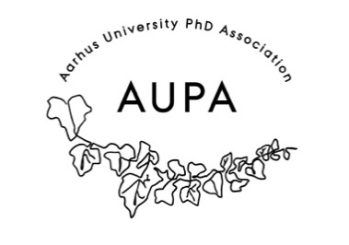
MINTES FOR AUPA’S BOARD MEETING
TIME: January 14th from 17:00-18:00
LOCATION:

Attendees: Stine, Sara, Michelle, Amanda, Rebecca
ABSENT WITH APOLOGY:

- Welcome

- Formalities

  - Election of chairman
  - Can this agenda be approved?
  - Approval of minutes from the last meeting (they are on the website)

- Today’s topics:

- KIP and meeting with the PhD School leaders – what do we want to talk about and how
  - How did it go?
    - Went well, they loved AUPAs ideas
  - What did we plan?
    - We will do faculty based networkning, and events
    - A bigger more unifying event
      - PhD day for all faculties
      - Put in calendar

- General assembly (updates)
  - Statutes/Atricles of association
  - Annual Report
  - Budget
  - Practicalities such as meeting room, invite, date…
    - When? March 10th 16:00-18:30
    - Deadline for sign-up: 8th of march
    - Food: Pizza
    - Location: Auditorium on Mat
    - 14 days before: send out all formal documents. Budget, statutes,
    - Contact all the local PhD committees.
    - Contact PhD School leaders.
  - Promotion:
    - Flyers to hang up
    - Social media (facebook, linked in, newsletter)
    - Phd Comittees (Expect that one person from each faculty joins)
    - PhD Schoolleaders invite and send invite(Expect that they send it out to each faculty and department)
    - Invitation should include a explicit want of help to plan
    - Add to sign-up form what people would be interested in talking about.
When should we be ready: 20th of February!!

Budget:
Approval and explanation

- Plans for the year 2026
  - When do we want to do these?
    - Speeddating: October
    - Posterpresentation (practice and networking) Student house: End of May
    - Conference 2026! Theme based discussion groups: Start December
    - General assembly: 10th of march
    - All Faculties PhD day: September
      - Stine, talk to Ann and find out what the budget is.

- What meetings do we want to invite the PhD Committee to?
  - August, November, February, May

- Self defence flyer
  - We are a group of colleagues working on a flyer about PhD “self-defense.” A group of French PhD students has made a very informative flyer (see attached), which we would like to translate and adapt to a Danish — more specifically, AU/Arts — context.
  - AUPA might help distribute the flyers
    - Sara sender til Kristian Langhoff Sørensen, CC andre
    - Send mail til Kristian om ægteskab i PhD vejledning
    - Svar og sig at vi går videre med det.

- Nytårrskur/Newyears cure:
  - Budget: How much was spent?

Next meeting when?
Send meeting invite 17th of February, 16:00
- Invite Amanda

