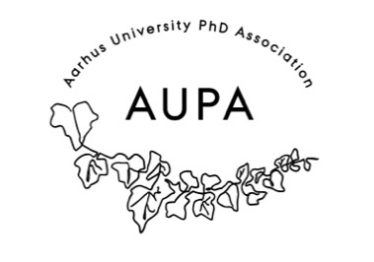
MINTES FOR AUPA’S BOARD MEETING
TIME: November 25th from 17:00-18:00
LOCATION: 1521-126

Attendees: Stine, Sara, Michelle, Rebecca
ABSENT WITH APOLOGY:

- Welcome

- Formalities

  - Election of chairman
  - Can this agenda be approved?
  - Approval of minutes from the last meeting (they are on the website)

- Today’s topics:
- December conference:
  - Speakers:
    - Karen Johanne Pallesen: The science of stress.
    - PhD skoleledere
    - Pernille Paabøl Svendsen: look at PowerPoint she sent us and report back to her with the time she will be speaking etc.
      - Wishes for a broader insight – Go beyond the thesis – maybe more interesting slides.
      - Michelle will reach out and help out.
      - Stine will reach out to Karen and let her know when and where.
    - What should we get the speaker?
      - Gift baskets
      - Rebecca orders.
  - Who will be the moderator?
    - Stine is moderator.
  - Activity group:
    - They are doing a quiz – pub quiz style.
    - So far the topic will be Christmas/holiday traditions in other countries – they will work on four more categories
    - Buy some glögg to drink while doing the quiz – catering from matkant? – coffee tea etc?
      - Order sandwiches from sunshine
      - Soda, Glögg, tea, coffee and hot chocolate from matkant.

16:00-16:15 | Welcome speech – presenting the theme of the day.
16:15-16:45 | 30-minute presentation from Pernille
16:45-17:00 | Break
17:00-17:45 | Karen Johanne Pallesen: The Science of Stress  AUPA preps questions – Q&A
17:45-17:50 | Present food and activity and let people know they can leave after
17:50-18:10 | Food and mingling
18:10-end | quiz– go home

- To Do: (delegation of tasks)
  - Name tags – Michelle checker om de har det på kontoret – Stine tager malertape med hvis der ikke er på michelles kontor (+ tuscher)
  - Rebecca orders food and drinks – food for 17:30
  - Rebecca orders gift baskets
  - Michelle writes Pernille
  - Stine makes rollups

Plan:
AUPA meets up 15:30 to set up

- PANDs event I next weekend:
- During your five minutes we put the focus on well-being practices at your university (group, department, all across).
  - Local initiatives, courses with wellbeing as a focus, workplace psychologists
- This panel therefore incentivises you to talk to your colleagues and do a little institutional-level mapping of what is going on.
- During your five minutes, or after, you can of course quickly share some related and aligned practise/proven tips&tricks that you do yourself (adding a personal touch)
  - Talk to your colleagues, engage in local initiatives, take walks/breaks, structure your workday, hold on to your values, do stuff in your free time, be okay with not always being productive

- Shubhangi stepping down from AUPA

Ekstra points?

Next meeting when?

