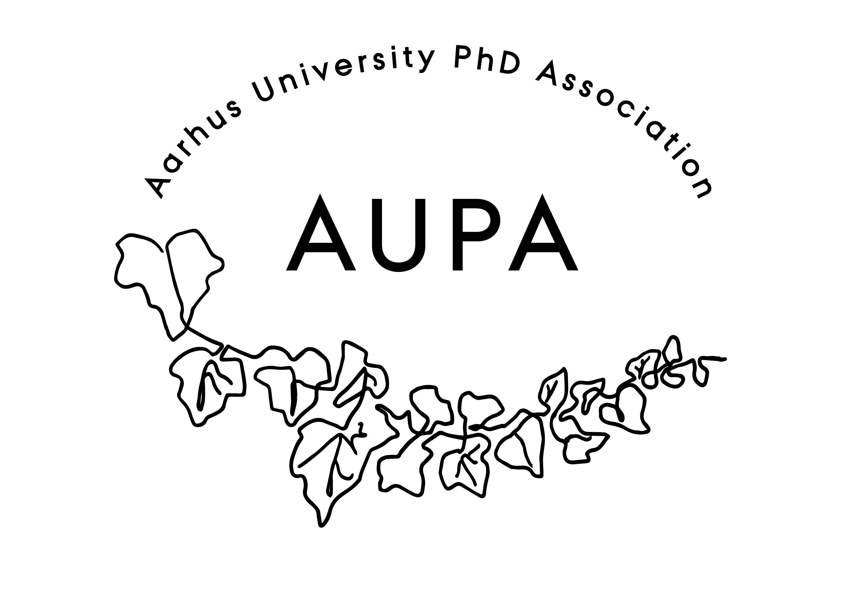
AGENDA FOR AUPA’S BOARD MEETING

TIME: 17.00 – 18.00
LOCATION:

Attendees:
ABSENT WITH APOLOGY:

- Welcome

- Formalities
  - Election of chairman:
  - Can this this agenda be approved
  - Approval of minutes from the last meeting (available via Teams)

- Compensation track: AUPA trying to get dissemination hours or compensation

- Update on budget and missing 21k

- News
  - PAND
  - HAMU

- Conference
  - Date: 6th October 2023, 18.00.
  - More specific thoughts on topic?
  - How do we ensure a good turnout?

- Emails

- Local PhD Associations
  - Election is upcoming and we have been asked to advertise

- Update on stress-coaching

- Deciding on the date for the next board meeting

- Any other business?
  - Topics for future agendas?
  - Refreshments:
    - Let’s appoint someone to take snacks, maybe we appoint a different member for every meeting, randomly.

