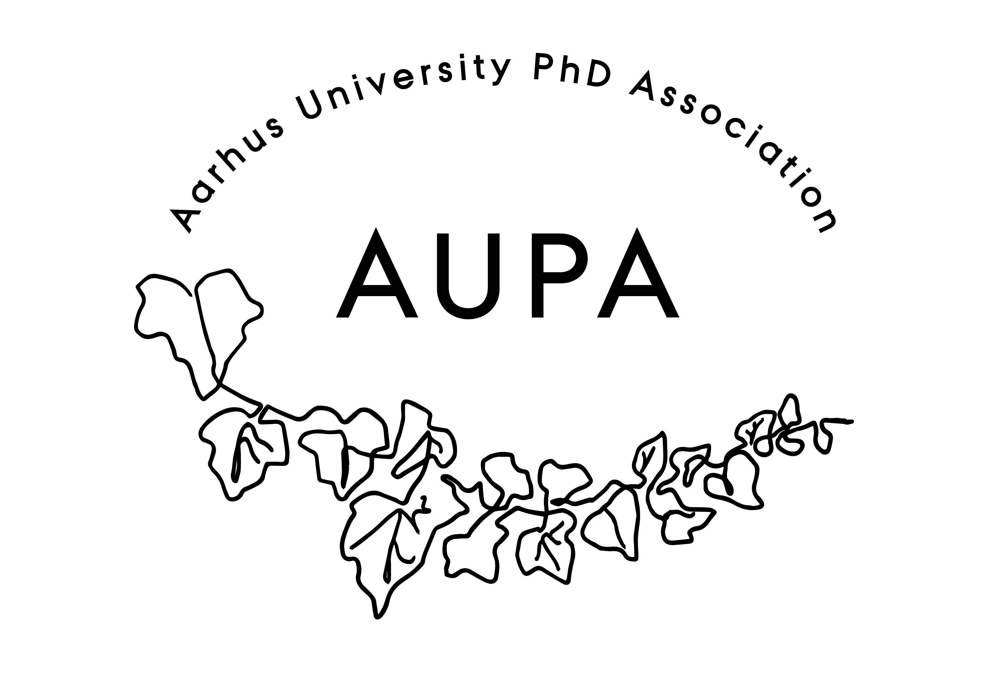
AGENDA FOR AUPA’S BOARD MEETING

TIME: 17.00 – 18.00
LOCATION:

Attendees: Fie, Martin, Thomas, Yane, Mathilde
ABSENT WITH APOLOGY:

- Welcome

- Formalities
  - Election of chairman: Thomas
  - Can this this agenda be approved
    - The agenda has been approved
  - Approval of minutes from the last meeting (available via Teams)
    - The minutes have been approved

- Compensation track: AUPA trying to get dissemination hours or compensation
  - No updates on this.
  - Martin will contact David to get an update.

- Update on budget and missing 21k
  - We are not missing 21.000kr, it was a misunderstanding.
  - Mathilde has written to AU Finance for an overview of our budget, and will update the budget on Teams accordingly.

- News
  - PAND
    - PAND is chaos
    - Retreat on the 13/08 to work on PANDs strategy moving forward
      - Francesco would like to join for the retreat
    - A lot of started projects, not many finished
    - Departmental letter to the universities for dissemination hours
    - Fie is stepping down from PAND (she is both treasurer and co-chair)
    - New funding scheme: All associations can apply for 10.000 before September 1st. After September 1st we can apply for the rest.
      - Apply for funding for the coaching
    - Fie will be administratively the treasurer for a while
    - Fie and Martin will make up a template for applying for funds from PAND
    - Who will apply for the money: Thomas will fill in a first draft for applying for funding for the Monika event
    - Cille will stay on at PAND
  - HAMU
    - There haven’t been any meetings since the last meeting
    - They would like more diversity in the workplace

- Conference
  - Date: 6th October 2023, 18.00.
  - More specific thoughts on topic?
  - How do we ensure a good turnout?
    - Cost: 19.500kr + travel expenses
  - Themes: Career clarification, how you can use your person in a career perspective, how to enjoy the PhD
  - 18.00-20.00 for Monika talk
  - Activity group will do something after – what?
  - Talk to AU Career about cooperation
    - Maybe Vibeke can talk before.
    - Thomas will write to Vibeke about the conference
  - Advertising this
    - Social media
    - Newsletters
    - Institutes, AU career
    - Posters?
    - Bente Pedersen
    - Monika can share it on her channels
  - Other tasks:
    - Martin, Francesco and Thomas will be the central working group for the conference

- Emails
  - No emails
- Local PhD Associations
  - Election is upcoming and we have been asked to advertise
  - We’re waiting on materials to send out
  - Improve co-ordination with local committees

- Update on stress-coaching
  - We have the application and recommendation
  - Contact with Bodil - She’s been active in applying for money and has written the application we have now
  - Place it with Career. We’re waiting on an answer from Vibeke
  - Discuss this next meeting
- Deciding on the date for the next board meeting
  - A doodle has been sent out

- Any other business?
  - Topics for future agendas?
    - Conference
    - Funding application
    - Coaching
    - Missing 21k
    - Dissemination hours
    - Meeting between different committees and AUPA
  - Refreshments:
    - Let’s appoint someone to take snacks, maybe we appoint a different member for every meeting, randomly.dood

