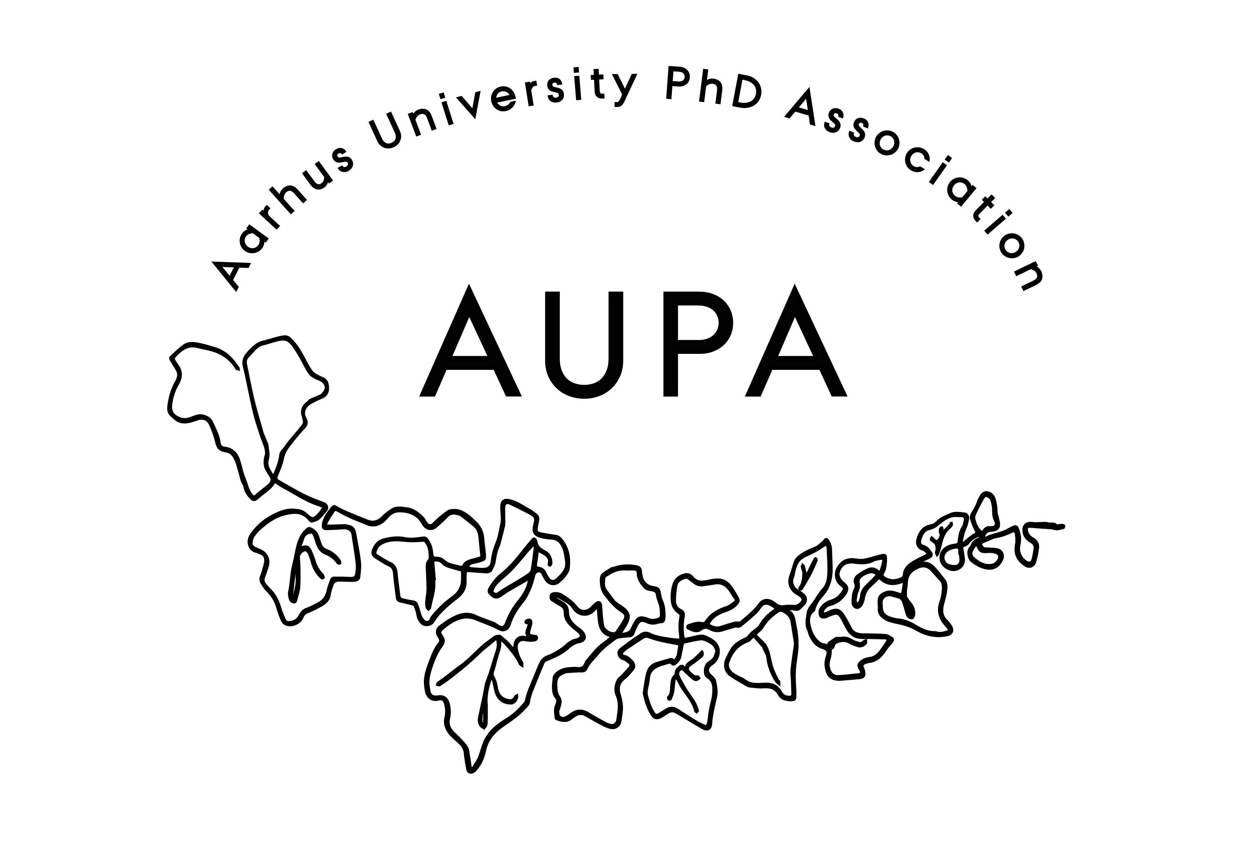
AGENDA FOR AUPA’S BOARD MEETING

TIME: 17.00 – 18.00
LOCATION:

Attendees: Cille, Thomas, Maria, Martin
ABSENT WITH APOLOGY: Fie

- Welcome

- Formalities
  - Election of chairman: Thomas
  - Can this this agenda be approved
    - The agenda has been approved
  - Approval of minutes from the last meeting (available via Teams)
    - The minutes have been approved

- Compensation track
  - No answer from David

- Update on budget and missing 21k
  - We have money.

- News
  - PAND
    - Thomas has written an application for PAND for 10.000kr
    - Comment on it if anything needs to be added
    - Two weeks ago there was a strategy retreat
    - AU hosted and PhD students from many universities were in attendance. It was a way to get to know each other and deal with internal changes in leadership. These positions haven’t been elected yet, but people are eligible to be voted into these positions – this has to be done at a GA. There will be an extraordinary GA – Cille can forward the information to the board.
    - New strategic focus:
      - Incorporate more universities in PAND
      - Better alliance across universities, where younger and smaller PhD associations will be heard.
      - Improve communication across universities & broaden the horizon of what they do in the organization.
    - In order to get funding, the event has to be available for all PhD students.

  - HAMU
    - No new meetings since last time.

- Conference
  - We have agreed with Monika on a concept and price
  - We have booked a room
  - Career will help out
    - Ask student assistant to help out on the day
    - Maria will book the car for the day to pick up Monika
  - First two hours: Workshop
  - Second two hours: Activity Group – Ask Emma tomorrow
    - Write that there is a social event after
  - Logistics: Which small tasks need to be done?
  - Funding: Still apply for the 10.000kr from PAND
  - Marketing: Can we get enough people to attend
    - Social media + newsletters
    - One-page PR material – send this out to PhD schools ASAP.
      - Make a link in the document and send it to Thomas
      - Send the document out to the faculty newsletters
      - Include the date in the document
    - Poster: Martin will make it
- Order paper + pens and name tags

- Emails
  - No new emails.
- Local PhD Associations
  - We should focus more on local associations. We should coordinate more with them.

- Update on stress-coaching
  - Thomas sent a grant application for AP Møller Fonden for stress-coaching.
  - We’ve been working with Kristoffer and Bodil Øster
  - It will be distributed and administered from AU Career. They’ll be administrating it. If we don’t get this money, we’ll apply for something new.
  - We have a list of different places we can apply for funds.
- Deciding on the date for the next board meeting
    - A doodle has been sent out

- Any other business?
  - Turn up for the meetings. Turnout has been weak since the summer holidays. Thomas will write to the people who have been unresponsive about whether or not they want to continue with AUPA.
  - Have a social event with activity group! Kickstart the board again.
  - Next introductory day is in October. AUPA needs a speaker here.
  - Refreshments:

