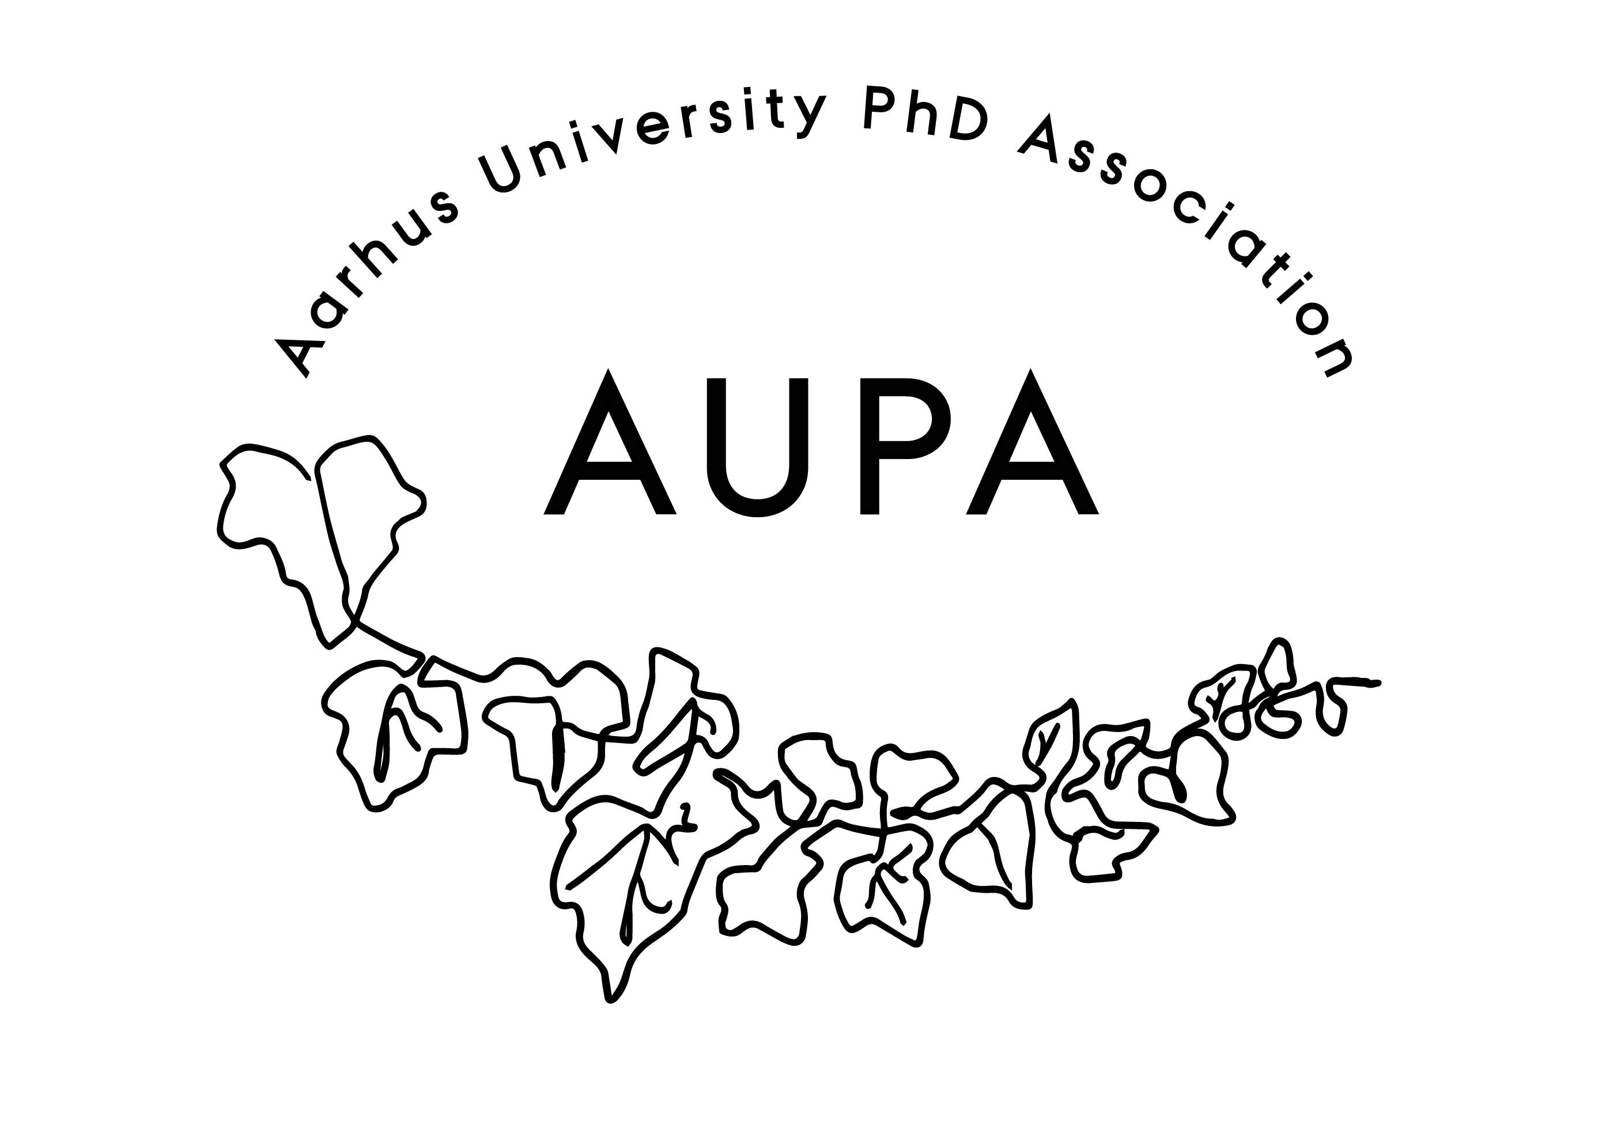
AGENDA FOR AUPA’S BOARD MEETING

TIME:
LOCATION:

Attendees:
ABSENT WITH APOLOGY:

- Welcome

- Formalities
  - Election of chairman:
  - Can this this agenda be approved
  - Approval of minutes from the last meeting (available via Teams)

- Compensation track

- News
  - PAND
    - Should AU continue supporting PAND? Followup on talks with Kristian
  - HAMU

- Conference

- Emails

- Planning future events
  - what should we apply for at PAND?

- Recruiting more members for AUPA
  - Can we send a common newsletter to all Ph.D.s?
- Deciding on the date for the next board meeting

- Any other business?
  - Refreshments: We will order food for the future meetings.
  - Future meeting focus:
    - Local PhD Associations
    - Update on stress-coaching

