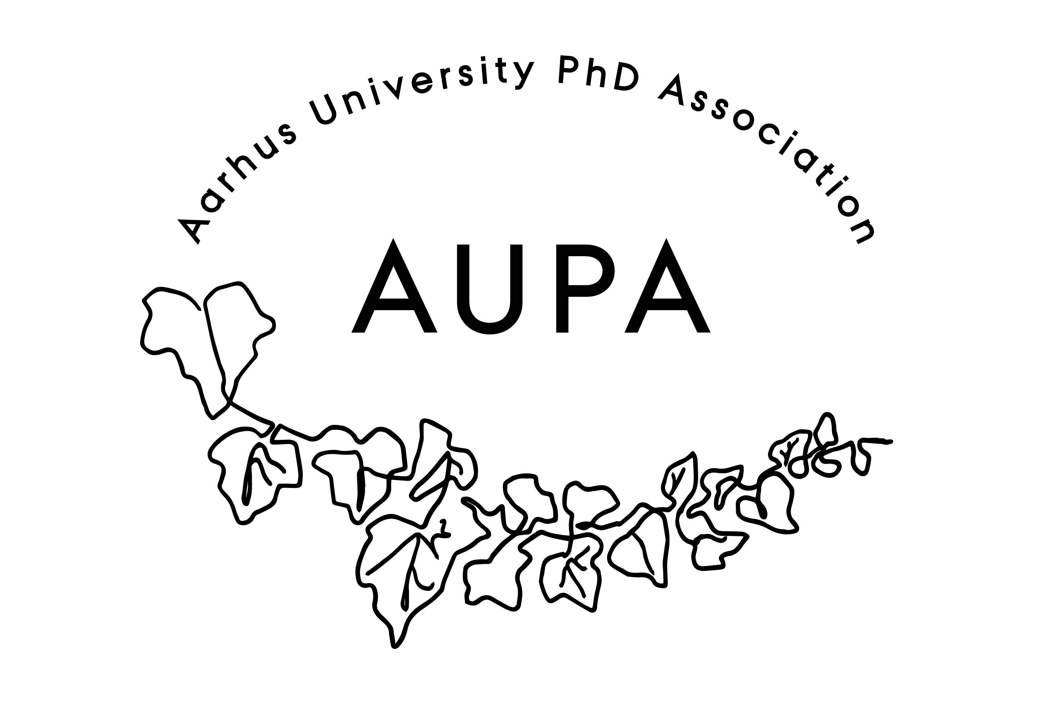
AGENDA FOR AUPA’S BOARD MEETING

TIME: 16.00 – 17.00
LOCATION: 5220 - 214

Attendees: Cille, Fie, Thomas, Martin, Yane, Malene
ABSENT WITH APOLOGY:

- Welcome

- Formalities
  - Election of chairman: Thomas Tandrup
  - Can this this agenda be approved
    - The agenda has been approved
  - Approval of minutes from the last meeting (available via Teams)
    - The minutes have been approved

- Conference
  - Thoughts?
    - Good turnout!
    - Next event should be more discussion-based, and not as lecture-based.
      - Applying future to the real world
    - Mixed reviews on the topic and speaker
    - A lot of people didn’t know many – there should have been more of a social aspect to the event
    - Newsletter is extremely effective in spreading information

- What should AUPA do?
  - Description: we will have a discussion about the purpose, goals, strategy and organization about AUPA. Please reflect on the following questions:
    - What is the purpose of AUPA? (Are we a social forum? A political lobby? Event managers/talent developers?)
      - Bylaws: Quite vague
      - Over the years: We have lost contact with the local student political organizations.
      - We don’t have a political agenda – but bringing people together across faculties is political. Bringing attention to cross-disciplinary issues/problems
      - Our core-function isn’t the events, but being representatives at HAMU, the wellbeing committee, PAND
      - We are only able to help PhD students if they know we exist. To do this, we have to hold events.
    - How do we operationalize goals into a long-term strategy
      - One task: Co-ordinate and facilitate discussion with the local associations
        - Thomas and Yane have been arranging meetings with all the associations to hear out what they have to say. It is within our mandate to coordinate and organize these groups
    - How do we organize the board and delegate responsibilities to achieve these aims?
      - Organize two core groups that will share updates at the board meetings. Social media is a distinct part of each group.
        - Strategy group: Thomas
          - About: We’re represented in various committees. We need to engage more with the associations and committees. To know what the political issues are with the PhD students, we need to have better contact with the PhD committees.
          - Help the associations coordinate their efforts
          - We’re not represented at all the introductory meetings, this should be another focus area. Thomas has written to all the graduate schools about this.
          - We need to be very clear about what we do, and what we don’t do. We need to be aware how all the events we have and the things we do that are distinctively AUPA.
            - It’s important to emphasize the social aspect.
        - Events group: Fie
          - Should be more coordinated with the Activity Group.
      - It should be facilitated through e-mail.
      - After each meeting in the minutes we should note who is in each group.
- News
  - PAND
    - 3 weeks ago PAND had a board meeting
    - PAND would like to have a more permanent place to have events and meetings. This could lead to an unfair centralization of the organization.
      - This defies the purpose of the organization
    - Thoughts on this?
      - De-motivating effect on people not in Copenhagen
      - What is the alternative? We can host each other every time. It should rotate.
      - It should be thought of more as a network between associations at different universities, rather than as an organization on its own.
  - HAMU
    - No updates
  - Emails
- Planning future events
  - Spooky projects: Should be postponed
    - Find a new date before it’s sent out in the newsletter. Martin will contact Emma
- Deciding on the date for the next board meeting
  - A doodle has been sent out

- Any other business?
  - Refreshments:
  - Future meeting focus:
  - Gruppefordeling:
    - Strategy group: Thomas, Martin, Yane, Cille, Malene
    - Events group: Fie, Martin

