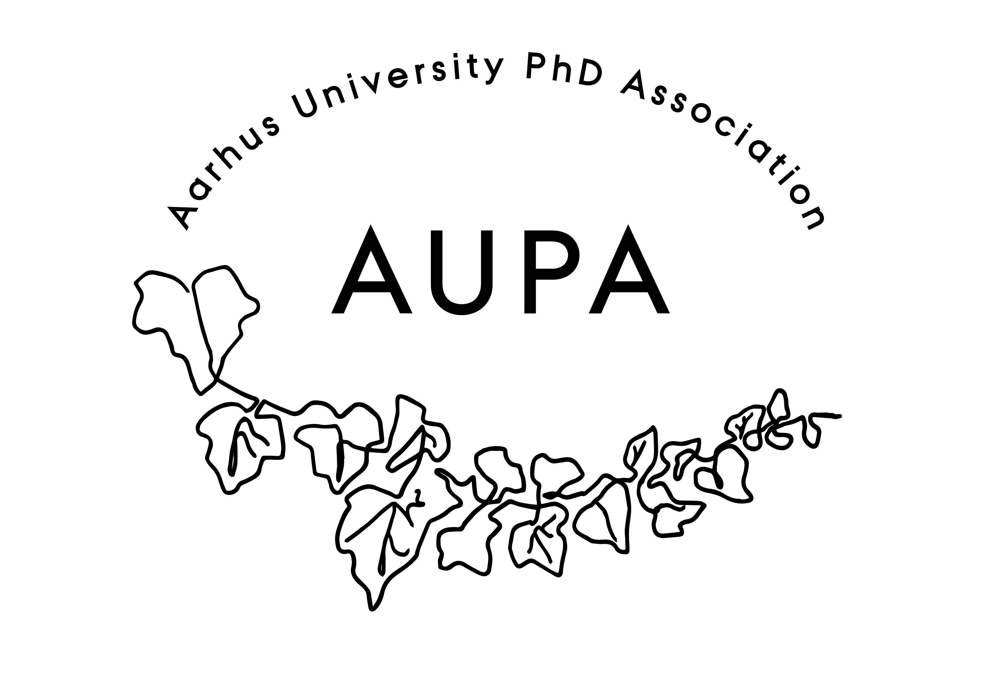
AGENDA FOR AUPA’S BOARD MEETING

TIME: 17.00 – 18.00
LOCATION: 5220 - 214

Attendees: Cille, Thomas, Maria, Fie, Hannah, Francesco, Lina, Shubhangi
ABSENT WITH APOLOGY: Ina, Malene, Martin

- Welcome

- Formalities
  - Election of chairman: Thomas
  - Can this this agenda be approved
    - The agenda has been approved
  - Approval of minutes from the last meeting (available via Teams)
    - The minutes have been approved

- Status from the strategy group:
  - Update from meetings with faculty committee chairs
    - Each faculty has a committee, where PhD students meet to lay a plan for the faculty, which goes down to the institutes
    - The organizational landscape is very complicated. Committees have no formal decision power, only the power that the leadership gives them.
    - There will be a meeting in the strategy group soon to discuss future work. After this they will contact chairs to hear what goals they have and how we can help them.
    - Create a community of people who are interested in changing and influencing the political landscape at the university. Organize a summit and put all organizations at an equal level. Identify issues/discrepancies across faculties.
      - Who is where, who does what, what interests do they have?
      - 1 summit each semester, and 1 wellbeing committee each semester.
    - Recruitment pipeline for AUPA: We need to be present at introduction days. Thomas and Yane have set this up.
  - Update from well-being committee meeting
    - Which political issues should AUPA work with?
      - Emotional and mental well-being
    - Well-being meeting: There is a theme each meeting, and they discuss possible solutions to the problem/theme.
    - Might be more evident which topics to bring up once we speak to the committees at the different faculties.
      - Make survey/focus group to discuss issues/problems.
    - The culture in these meetings is not very political – it is a lot more administrative. Long solution waiting times.
      - The administration tends to be ineffective when it comes to problems at the PhD level.
    - Yane will find the wellbeing report at present the main findings at the next meeting

- Status from the events group:
  - Meeting with Activity group on October 30th
    - Talked about events for the rest of the year.
    - AUPA will join forces with activity group now.
    - Anyone who wants to help! Please join the events committee.
  - Several events in pipeline
    - Spooky projects
      - November 29th at 5.30.
      - Martin has written a description.
      - Both AUPA and Activity Group. 5 minutes scary stories.
      - Prize for the best story. Visiting the student bar after.
      - Need to make social media content and maybe posters.
    - Board games: November 16th at Brætspilscafeen.
      - This is mostly social group.
      - AUPA can maybe give one drink
    - AI event with Jes Harfeldt suggested by Malene
      - Alpha Go
      - AI movie night
      - Sometime in January
      - Apply to Danish data-science academy for funding
      - Apply for money for Jes to come. Two separate events (Jes and AI movie night).
        - Jes is an associate professor at AAU (has a podcast about AI). Talks about how to use AI in research/academia
    - Lotte Luscher (collab. with HE-PhD association)
      - Further coordination is necessary.
      - Collab with HE-association. Contact person: Sofie.
      - How to create better communities for PhD students
      - February at the earliest.
    - Guided tour 02/12 (Activity Group)

- News
  - PAND
    - No updates.
    - They’re launching a writing competition.
    - Eurodoc – European PhD Association
      - Next meeting is up for grabs – PAND will be present here.
  - HAMU
    - No updates.
  - Emails
    - No emails.
- Deciding on the date for the next board meeting
  - A doodle has been sent out

- Any other business?
  - Refreshments:
    - Christmas lunch with AUPA and Activity Group!
  - Future meeting focus:
  - Groups:
    - Strategy group: Thomas, Cille, Maria, Yane, Malene, Hannah
    - Events group: Fie, Shubhangi, Martin, Lina

