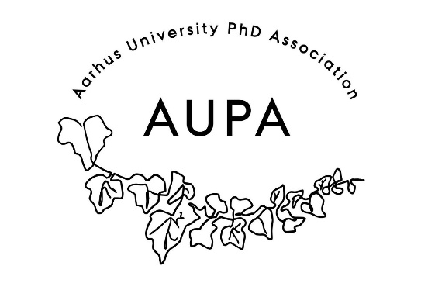
AUPA General Assembly Minutes
23-03-2026
- Presentation of AUPA
  - What have we done: conferences,
  - Representing all faculties of PhD – new thing is having 4 meetings a year with the PhD committees
- Activity Group:
  - A way to meet other people, from other departments
  - Facilitating events across faculties
- Budget was presented, and approved – unanimous
  - People had questions about the delegation of money and the categories that the budget is split into.
  - People had questions about “AG” – we should clear up that it is Activity group
- Going through the by-laws:
  - Change paragraph 5
  - Delete sentence in paragraph 6
  - Change paragraph 2 to state that it is PhD Students
- Election of chairperson: Stine is elected as chairperson
- Election of co-chair: Sara has been elected as co-chairperson
- Election of treasurer: Mark has been elected as the new treasurer
- Board of AUPA: Ida, Jeanine, Jan, Michele, maria

PhD careers outside of academia:
- Good course at arts with a speaker we could hire – Sara knows
- Very relevant
- Could be focused on the skills or qualifications that you need to join industry – interviews, practical experience etc.

Expenditure for General assembly:
- Soda and tea: 607dkk
- Pizza: 1374dkk
- Plates: 75dkk

