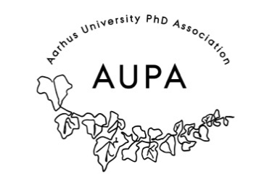
MINTES FOR AUPA’S BOARD MEETING
TIME: April 21th 2026 from 17:00-18:30
LOCATION: 1521-116

Attendees:
Absent with apology:
- Welcome
- Formalities
  - Election of chairman
  - Can this agenda be approved?
  - Approval of minutes from the last meeting (they are on the website)
- Today’s topics:

- PhD day – AUPA event
  - Theme: Preparing for jobs after PhD both in/out of academia
  - Have a paneldiscussion – speakers with different experiences
  - Michelle might have a contact, maybe Søren S. E Bengtsen
  - September 2026
  - How to apply for funding
- Planning poster presentation workshop – w/activity group? In May
  - Maybe have someone talk about how to present?
  - Prepping for conferences with posterpresentations
  - Showing your own poster, get feedback?
  - Find someone at AU?
  - Have a planning meeting – to figure out details. Doodle (mid/end April)
  - Ask AG what they want their role to be
- Meeting with PhD committees in May
  - If we have a hard time getting them to come to our meetings, maybe we should go and visit them, so show some good faith
  - Stine will make a list – of the comittees and the elected people

