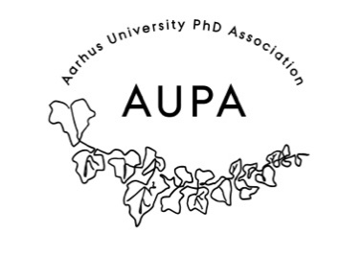
MINTES FOR AUPA’S BOARD MEETING
TIME: May 11th 2026 from 17:00-18:00
LOCATION: 1521-116

Attendees:
Absent with apology:
- Welcome
- Formalities
  - Election of chairman
  - Can this agenda be approved?
  - Approval of minutes from the last meeting (they are on the website). Approved
- Today’s topics:

- PhD committees meeting (local PhD committees)
- Poster presentation workshop
- Meeting with HE PhD Association (update)
- Update on PhD day event

Extra points:
Next meeting when?

