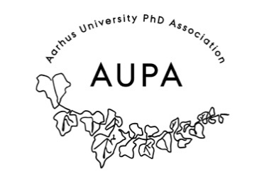
MINTES FOR AUPA’S BOARD MEETING
TIME: June 8th 2026 from 17:00-18:00
LOCATION: 1521-116

Attendees:
Absent with apology:
- Welcome
- Formalities
  - Election of chairman
  - Can this agenda be approved?
  - Approval of minutes from the last meeting (they are on the website). Approved
- Today’s topics:

- Update on PhD committees meeting (local PhD committees)
- Update on PhD day event
  - Speakers_:
    - Thomas Hessellund Nielsen (PhD career in region) will attend the panel discussion
    - Ask Jan: who did he get? Is presenting
    - Invite: Ana Donate – PhD in Psychology
    - Waiting for confirmation from Sebastian from the kitchen
  - Catering
- Venue:
  - Rebecca will ask Studenterhuset if they are available on the 22nd or 7th
    - Do they have cutlery/plates – no
    - Is cleaning included - yes
- Budget:
  - 10.000 PAND
    - no
  - 25.000 PhD school leaders
- Summer Holiday

Extra points:
Next meeting when?

