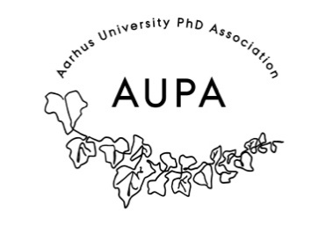
MINTES FOR AUPA’S BOARD MEETING
TIME: June 8th 2026 from 17:00-18:00
LOCATION: 1521-116

Attendees: Stine, Simon, Rebecca
Absent with apology:
- Welcome
- Formalities
  - Election of chairman
  - Can this agenda be approved?
  - Approval of minutes from the last meeting (they are on the website). Approved
- Today’s topics:

- Update on PhD committees meeting (local PhD committees)
  - Very successful meeting, they would like more focused subjects
  - ARTS Were very happy with the meeting – head of institute will help make a association on head of culture. Meeting in August.
  - Big interest!
  - Next topic: wait till after summer
    - Making guides

- What can AUPA do: How university politics work – election workshop, extra curriculars, what boards work best for what.
- How to engage in university life: How do the asscoations work? What are your options for social life? Sharing best practices from different departments.
  - Make these kinds of Hubs, and share them in the common meetings across faculties.
  - What to do differently:
    - Make sure that the IT stuff works – PowerPoint w. separate Menti
    - More people, more faculties/diversity in attendance
  - What was good:
    - Break out rooms
    - Good with menti notes
    - Keep it at 1,5 hours
- Update on PhD day event.
  - Speakers:
    - Thomas Hessellund Nielsen (PhD career in region) will attend the panel discussion
    - Vibeke Broe – PhD career service (have her own talk – an introduction – how they can help and what their services are)
    - Waiting for confirmation from Sebastian from the kitchen
    - Cecilia – international postdoc (academia – panel)
    - Jeanines contact – did he agree?
    - Ida contact – who?
  - Catering
- Venue:
    - Studenterhuset: 22nd – wrirte back to Jo
    - Do they have cutlery/plates – no
    - Is cleaning included - yes
- Budget:
  - 10.000 PAND - no
  - 25.000 PhD school leaders - Maybe
- Summer Holiday
  - No meetings in July
  - Next meeting: second half of August
- Elections 2026
  - Big election year
  - They elect the board for AU
  - Making an election meeting – teach people about the election – who can run and who can vote? What can you run for if you are 4+4/3+5
    - Reply to Charlotte: We are hosting an information day event to let people know how the elections work.
    - Have the names of the people on the PhD committees available if people have any questions.
      - Oversigt over PhD valg.
    - Could the 5th of October be a good date to do this?
    - Send out flyers to promote the event - both about what the elections are and what the meeting will be about.

Extra points:
- After summer holiday: election meeting
- Efter that: plan common meetings
- Stine writes to PAND and asks for them to send the e-mails to board.aupa.
Next meeting when?

