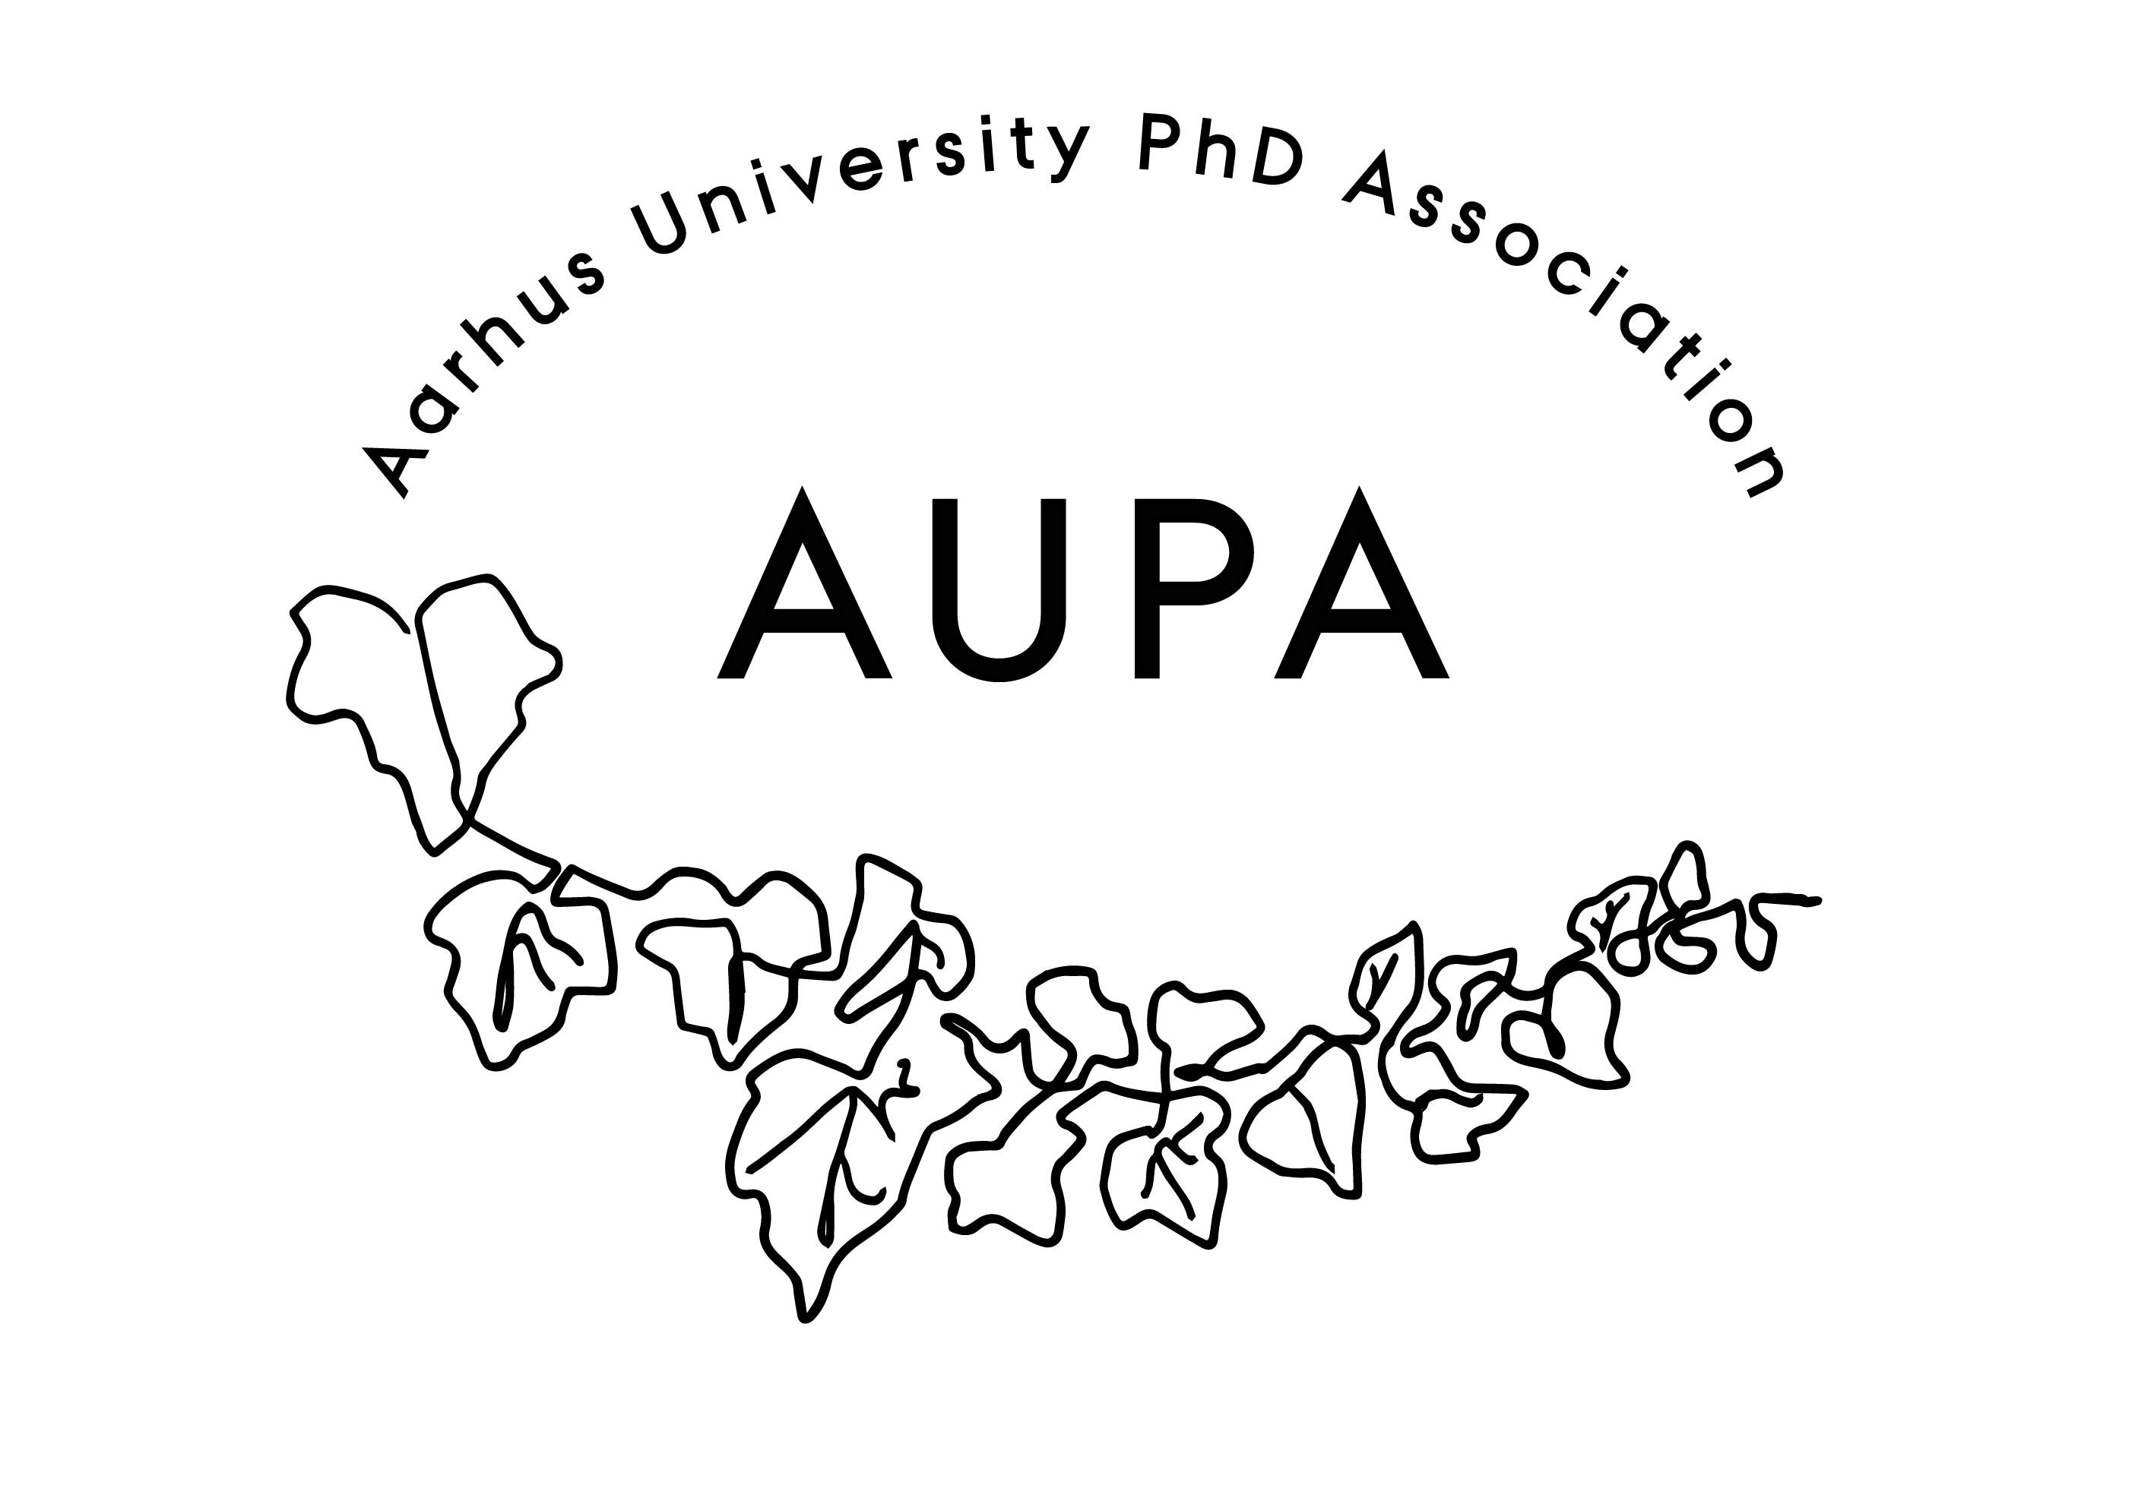
AGENDA FOR AUPA’S BOARD MEETING

TIME: 16.00-18.00
LOCATION:

GUESTS:
ABSENT WITH APOLOGY:

- Welcome

- Formalities
  - Approval of minutes from the last meeting (available via Dropbox)
    - The minutes have been approved

- Election of positions
  - Chairman: Kristoffer Ibsen
  - Vice-chairman: Mario Rincón
  - Treasurer: Hadi Sehat
  - Sub-committees:
    - Communication: Oscar, Juliane
    - Wellbeing committee: Shokouh, Hadi, Kristoffer
    - Conferences and events: Lina, Mario
      - Workshops
      - Logistics
      - Communication
    - PAND: Katia

- Goals for the year
  - Internal goals:
    - Increase visibility of AUPA
    - Communication channels:
      - Social media (Facebook, LinkedIn etc.)
      - Faculty newsletters
      - Omnibus
      - Department meetings
        - Slides about who we are/what we do
    - Collaboration with the PhD and Postdoc Activity Group
    - Email-list of PhD students
      - Not allowed, but newsletter may be the next best way of communicating to larger groups.
    - Talk to AU communication about promoting AUPA
    - Make a template for advertisement
    - Advertise AUPA at supervisor course. Have them tell their students about it.
  - External goals:
    - Improving the PhD journey
    - We can have smaller workshops with the leftover money from the last conference
      - Two or three workshops during the year
        - First one end of May, start of June.
        - Around the 20th-24th of May
      - Topic:
        - Imposter syndrome
        - Pitching and public speaking
        - Career opportunities/planning
        - Mental health during the PhD journey
    - Big conference: January

- Three Minute Thesis on the 17th of March
  - Mario will be a judge

- Health event on the 24th
  - Share the event
  - AUPA flyer
  - Can someone introduce AUPA at the event?
    - Juliane can do that!

- Meeting with the wellbeing committee
  - Our focus: Onboarding and communication
  - Nothing concrete was decided at the meeting
  - Different graduate schools all have different interests
  - The faculties will each try to implement onboarding, where they will pick and choose from toolbox from Nat.
  - Heads of graduate schools will make suggestions on changes at the AU level that will affect all
  - AUPA can work with PhD administration on smaller initiatives that we would like to implement
  - 30-minute meeting on Thursday where we will talk about Covid-19 and inconsistencies of extensions

- Deciding on the date for the next board meeting
  - A doodle has been sent out
  - Dinner afterwards

- Any other business?

