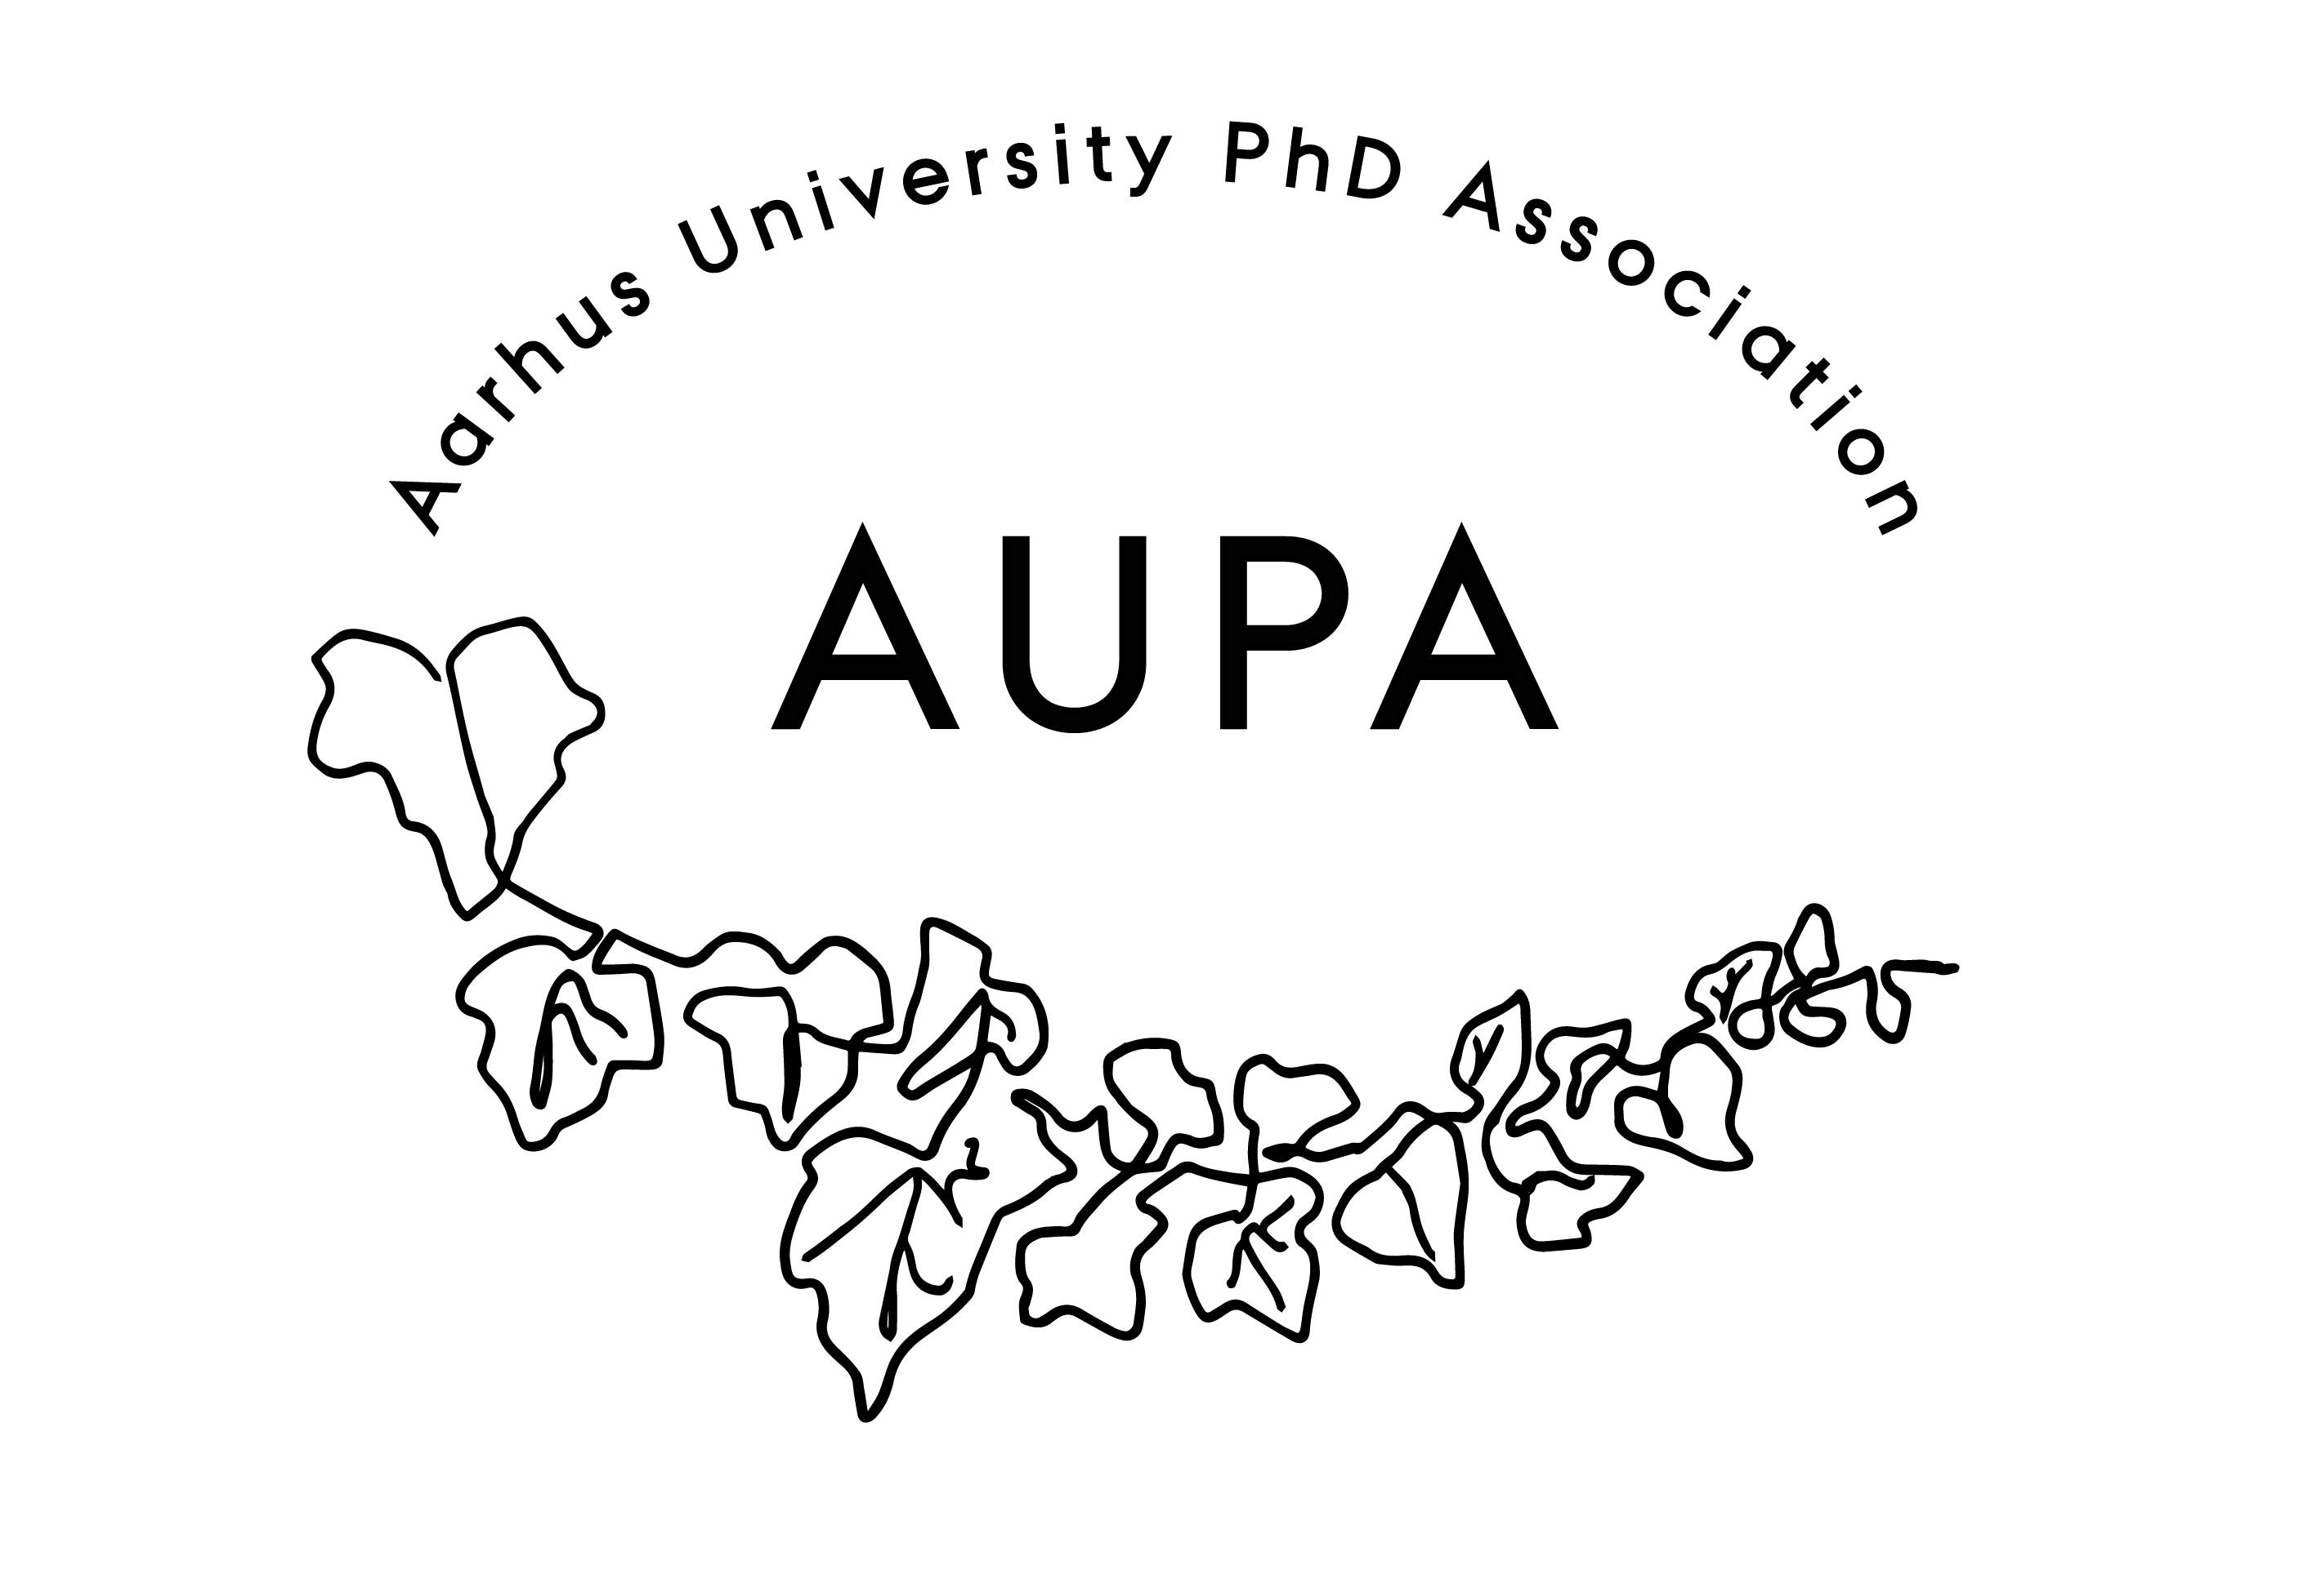
AGENDA FOR AUPA’S BOARD MEETING

TIME: 17.00-18.00
LOCATION: 5220 - 214

GUESTS: Cecilia
ABSENT WITH APOLOGY:

- Welcome

- Formalities
  - Election of chairman: Martin
  - Can this this agenda be approved
    - The agenda has been approved
  - Approval of minutes from the last meeting (available via Teams)
    - The minutes have been approved
- News
  - PAND
    - There was a meeting. A new proposed model for how to apply for funding in PAND
    - There has been discussion on changing the way funding applications should be done
    - PAND wants the application to work retroactively
    - They want to restrict the money already given
    - We have gotten approval that we have gotten money from things
    - We would be restricted – it’s not fair that we have gotten approval and then they change the rules.
    - GA on the 21st of April. Fie will ask if we have gotten the money and what additional information they need to pay.
    - Send the invoice from Frank to PAND
    - People are fleeing from PAND – no one wants to be chair. It is a very unstructured organization.
    - We can have three representatives from AUPA in PAND. It would be nice to have some sort of chair role, but it would be great if AUPA had more people in the board.
    - PAND gets a lot of resources. They have had a lot of events in Copenhagen. There’s a lot of potential to be able to make a difference.
    - RUC and SDU aren’t represented in PAND. There are 8-10 people in the board. 4 people are stepping down.
    - Francesco can join PAND along with Fie and Cille.
    - They have closed for sign-ups at the GA – is there anything we want to bring up?
    - Send Francesco Pernille fra AU Økonomi kontakt.
    - Open letter to universities about different teaching obligations. Employment stop – what does this mean for ph.d. students?
    - Unequal ECTS points across universities
    - DM have a phd survey every year. Share this survey when we get it. The survey is for all ph.d. students.
    - PAND will make some marketing material, so we have something to distribute.
  - HAMU
    - No update.

- Wellbeing committee
  - No update.
  - There are 3-4 meetings per year. Next meeting is next month.
  - Preemptive work with resilience meeting. Purpose to combat and prevent stress. If it becomes too fluffy, it is something we could invite PhD students to come for a coffee. It’s a supportive group thing. The idea behind it would be to support mental health.
    - We could consider starting something less fluffy
    - If nothing has happened by next meeting, it is something we can consider
    - Look for wellbeing report
- How to get more board members
  - E-mail
    - Få hjælp af Kristian om at sende ud til fakulteter
  - Possibility of getting dissemination hours/ECTS points for joining AUPA?
    - Martin sent an email to the head of the phd school at MBG. He is also the head of the wellbeing at the university
    - It has been discussed before ,but no agreement was reached. It would be a difficult time justifying ECTS – more open to dissemination hours. It is work being put in. he is leaning towards registering it as work and getting paid for working hours.
    - Then they need to find money – doesn’t necessarily help with the problem that people don’t feel that they don’t have time.
    - He is now actively working for it – pushing for paid work and if that gets pushback, suggestion of dissemination hours. He is discussing it with head of Nat. Until next meeting we will see if he has done something. If not, we will push him.

- Goals for the year
  - Communication/visibility
    - Newsletter
    - Push Emma for newsletter login information – possibility of making it AUPA and PhD & PostDoc Activity Group
    - Be more active on social media
    - What would we put in the newsletter?
  - Conference
    - Just after the summer holiday
    - Project management as the topic
    - Fie has a contact who could be a speaker – she has contacted them.
    - End of September. The introduction days are in the middle of the month, we could reklamere for it here
    - Friday the 29th
    - Workshop before then.
    - Classroom style room – book this ASAP
    - Talk to Emma about social event after .
  - Calendar wheel

- Emails
  - Miriam Kobbersmed: Ph.D. Career day participation
    - 27th of April. We should have a stand.
    - Bring flyers and roll up
    - Martin and Francesco will join as AUPA. Mathilde will join as well.
  - How do we proceed with case about unequal ECTS points across universities?
    - Bring this up at PAND GA. Could we get a statement from PAND? This could further our case at AU? It is our domain to petition AU to change.
    - Health was dissatisfied with different ECTS
    - We’ll write to those responsible for the courses at AU and confront them about the difference. Thomas will write back that we will take up the case and contact the course coordinators to justify the difference. Thomas will write to the course coordinators.
    - We cant make them change it retroactively
  - Ker Sin: Talk on career paths after PhD
    - Thomas sent them to AU Career

- Deciding on the date for the next board meeting
  - 2-3 weeks 4-6
- Internal social event to onboard the new board?

- Any other business?
  - Other potential events
  - Agenda – next time focus on the communication
    - Time after that focus on the conference

